|  |
| --- |
| Handout Measurements  Couple different plots to characterize the Demonstrator  **Autoren:**  **Jonas Künzli**  **Marina Homs**  **Rene Zurbrügg**  June 2019 |
|  |

Contents

1 Calibration 3

1.1 Voltage 3

1.2 Current 5

2 Output Current vs. Output Voltage 6

2.1 Precision Supply 6

2.2 Variable Supply 7

2.3 Body Bias 8

3 Load Response 10

3.1 Precision Supply 1 10

3.2 Precision Supply 2 11

3.3 Variable Supply 1 13

3.4 Variable Supply 2 15

3.5 Variable Supply 3 17

4 Measurements 19

4.1 Voltage 19

4.1.1 VM 1 19

4.1.2 VM 2 20

4.2 Current 21

4.2.1 CM 3 21

4.2.2 CM 4 22

# Calibration

## Voltage

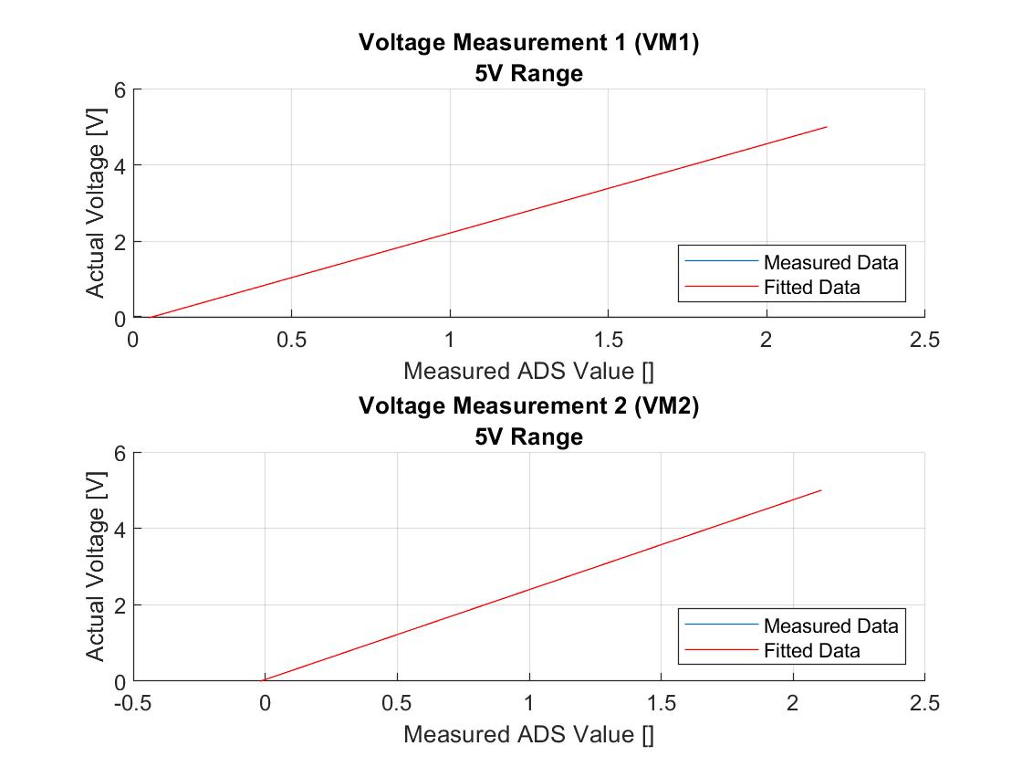

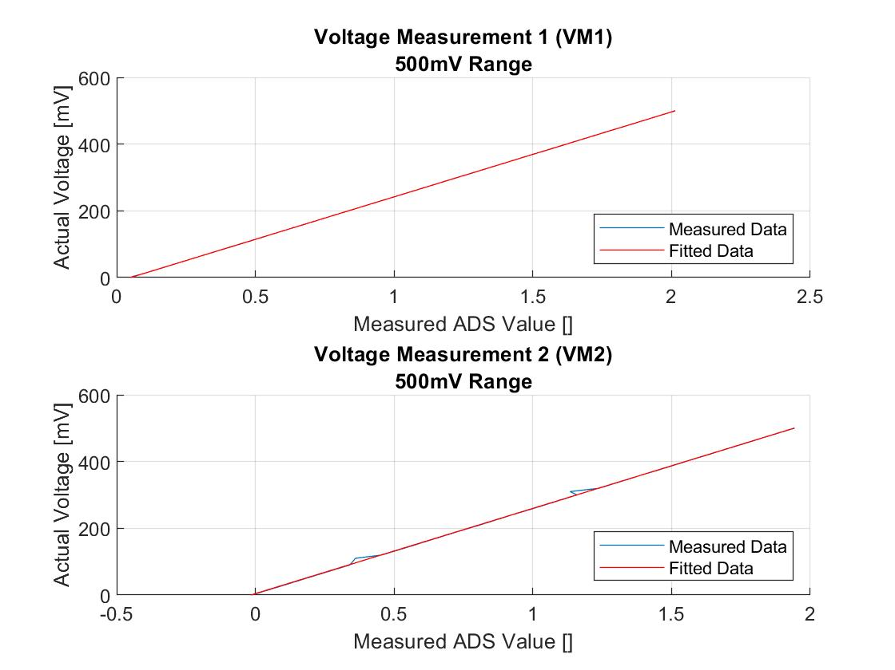

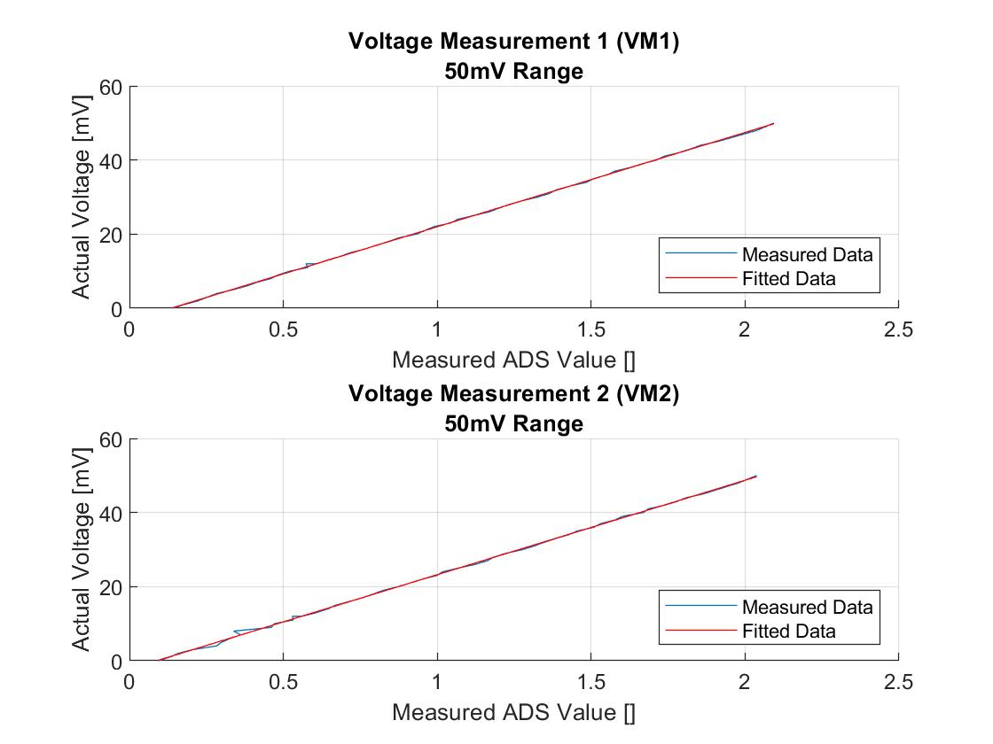

## Current

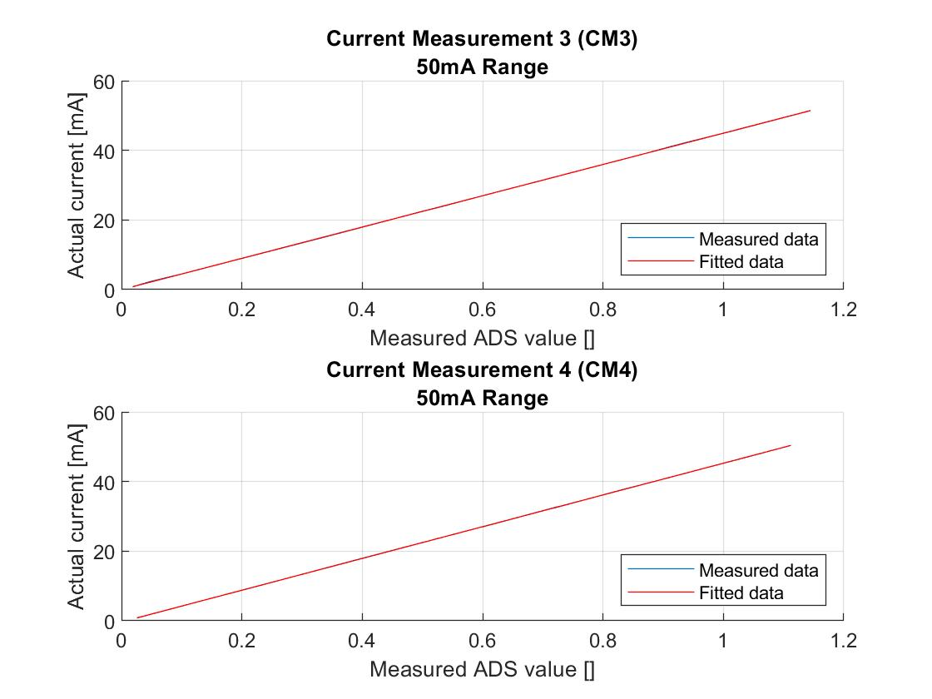

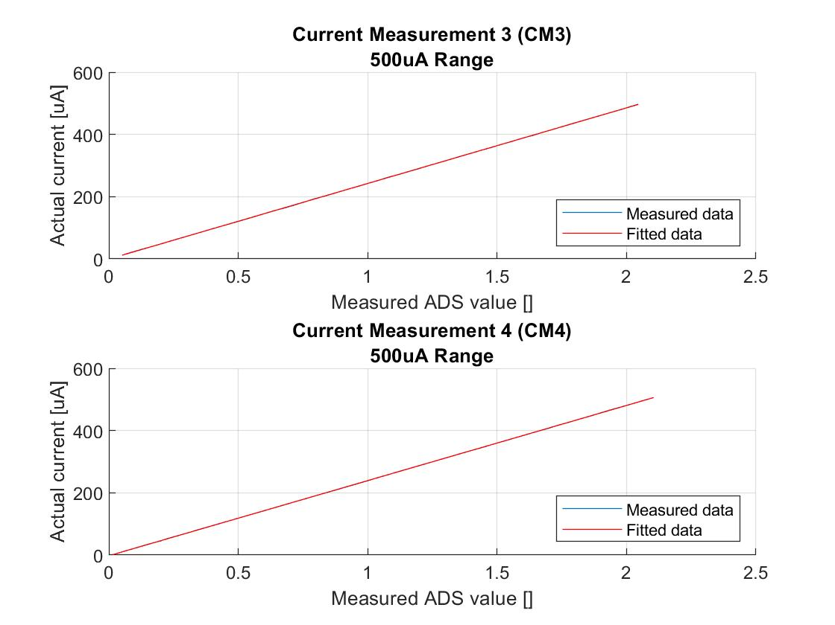

# Output Current vs. Output Voltage

## Precision Supply

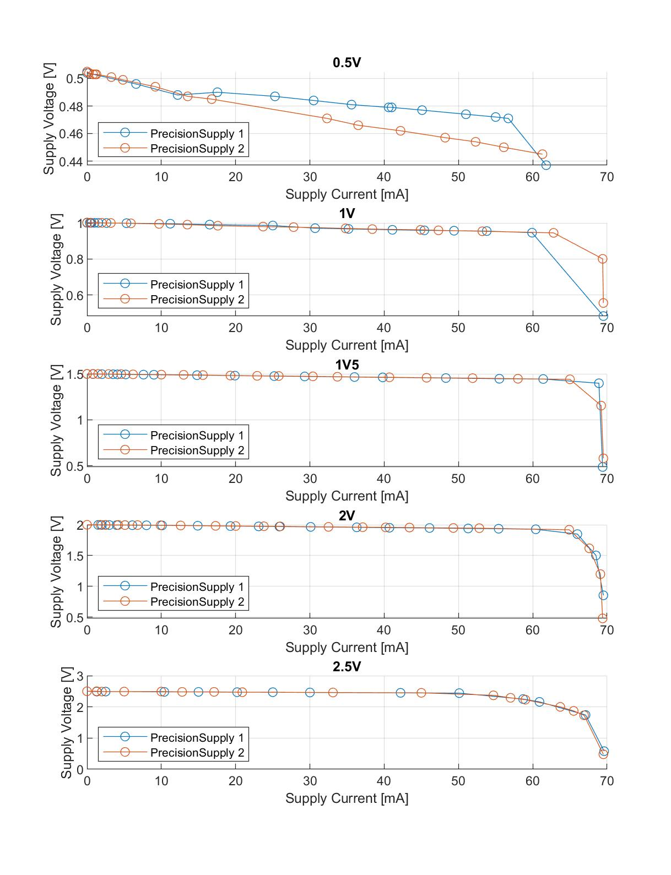

## Variable Supply

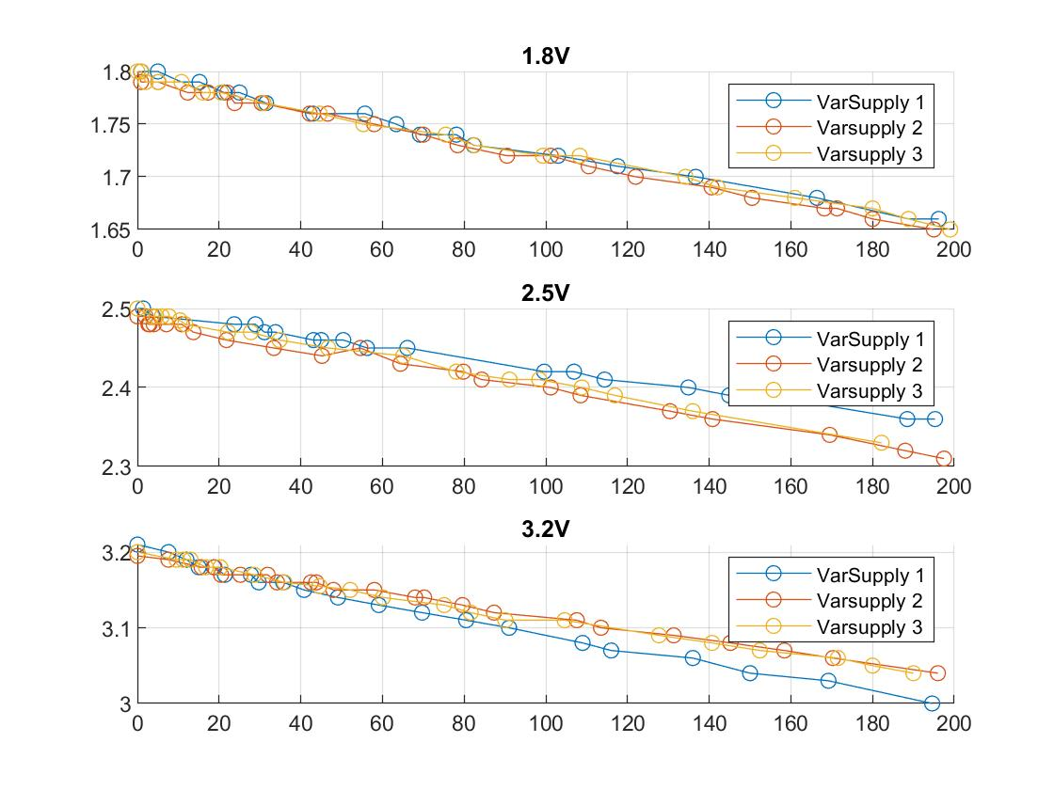

## Body Bias

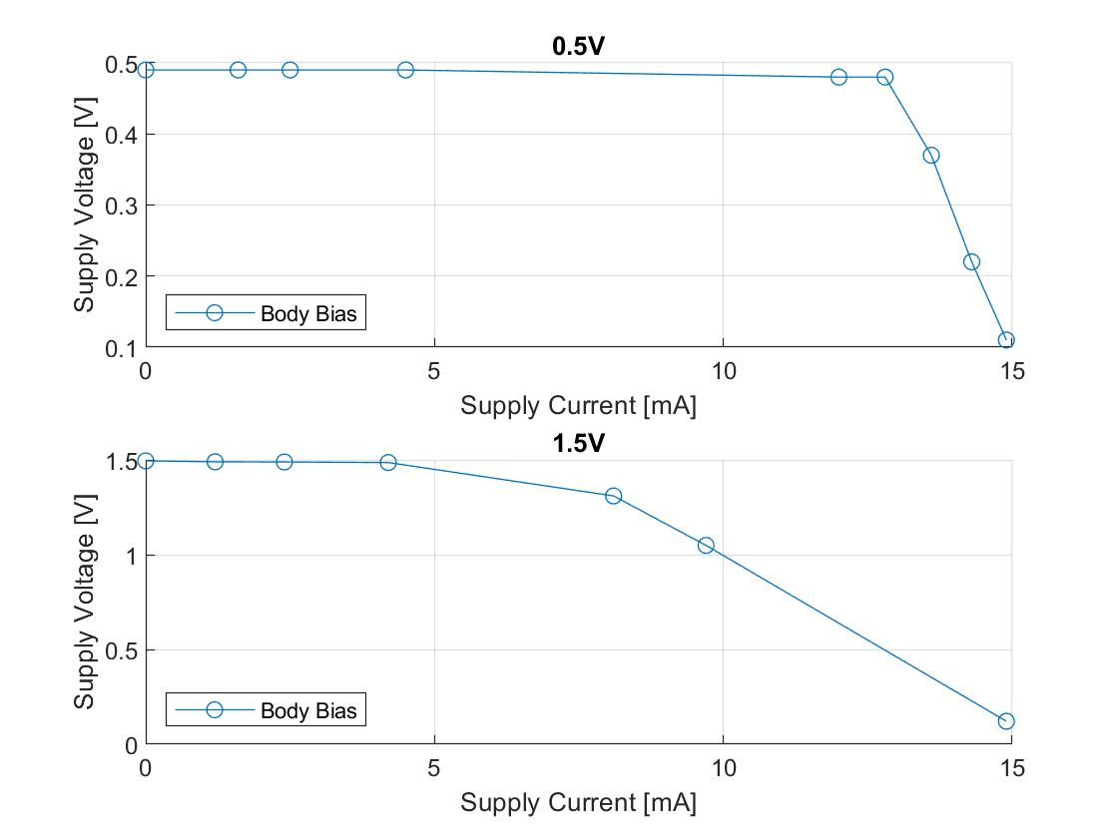

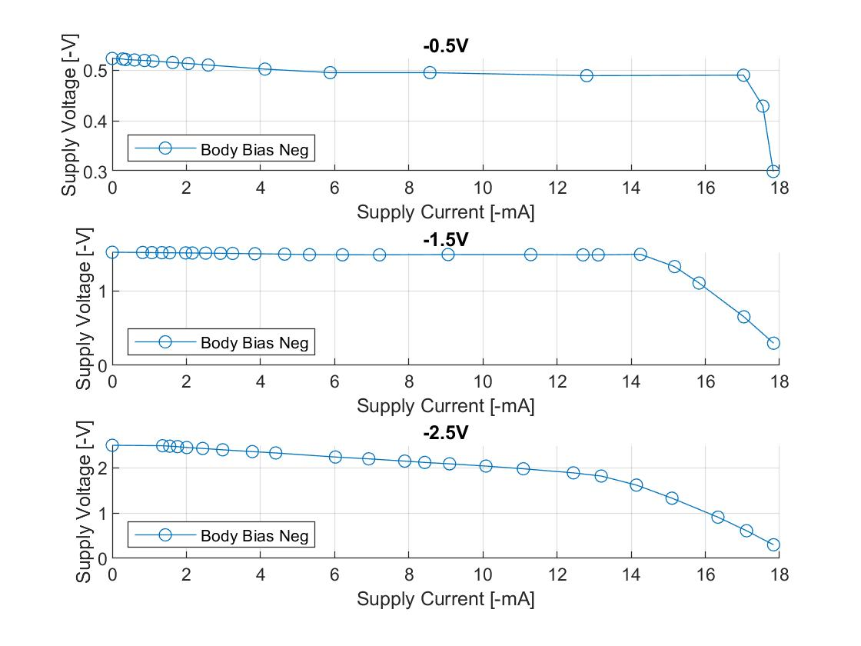

# Load Response

## Precision Supply 1

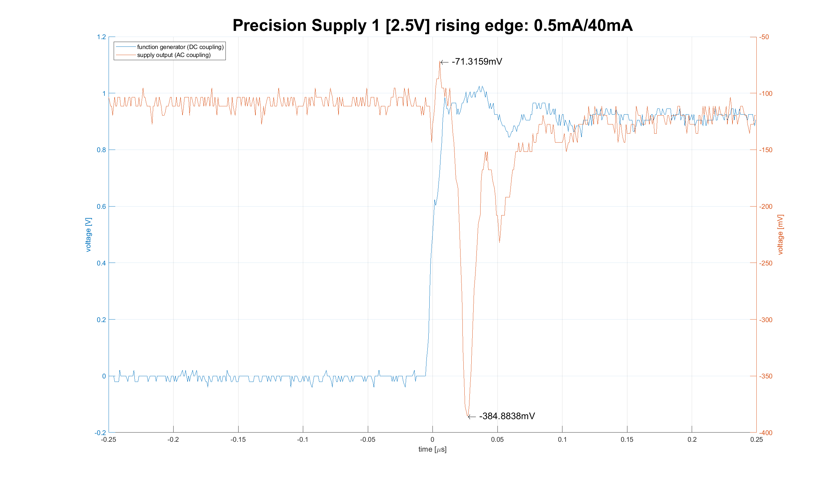

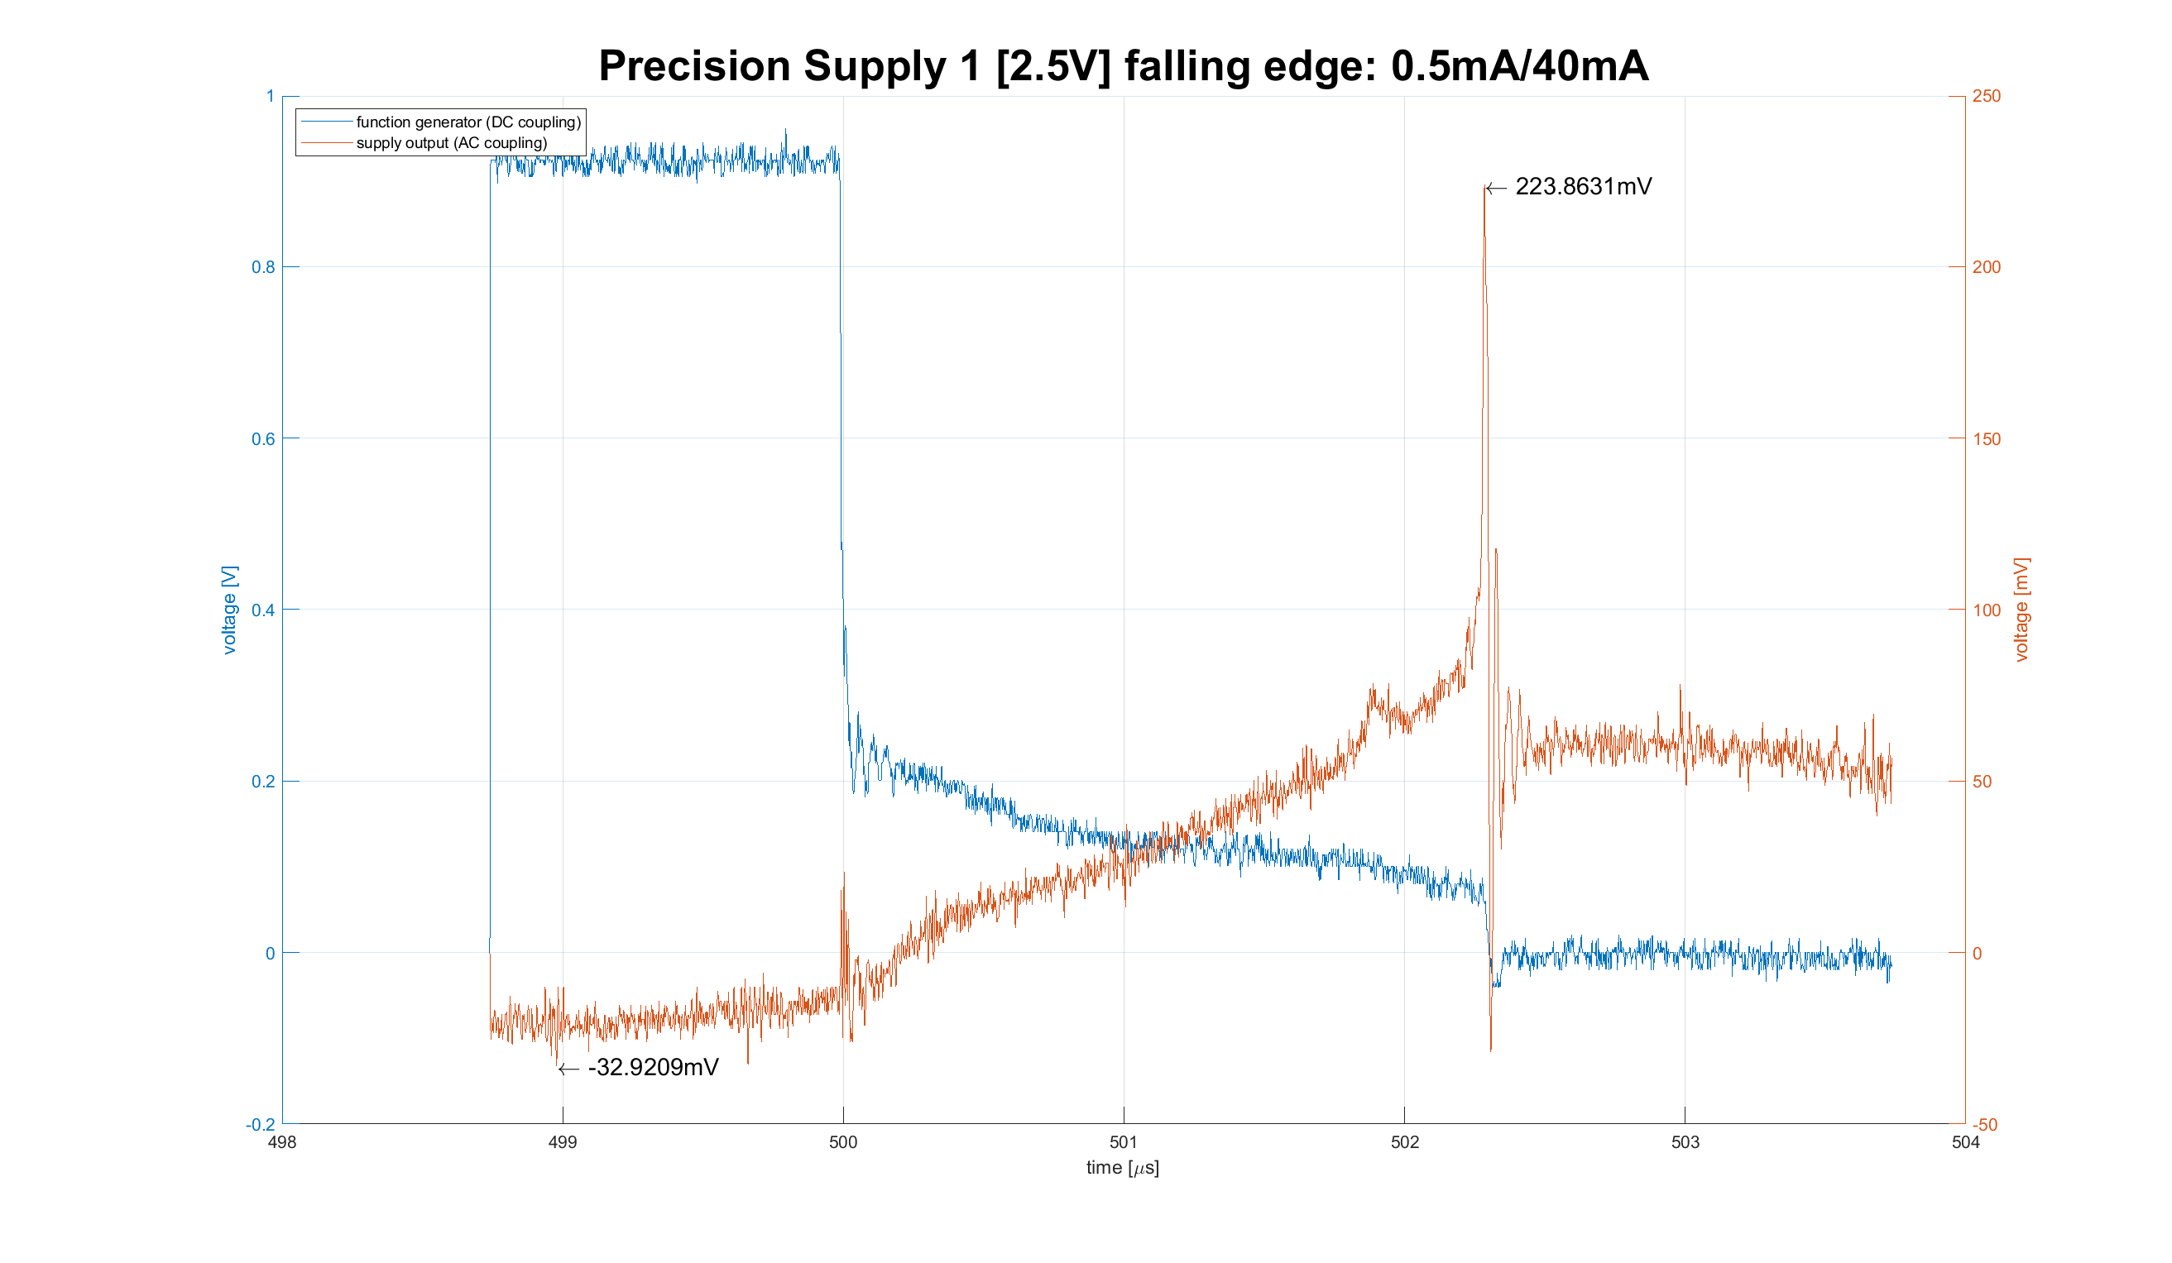

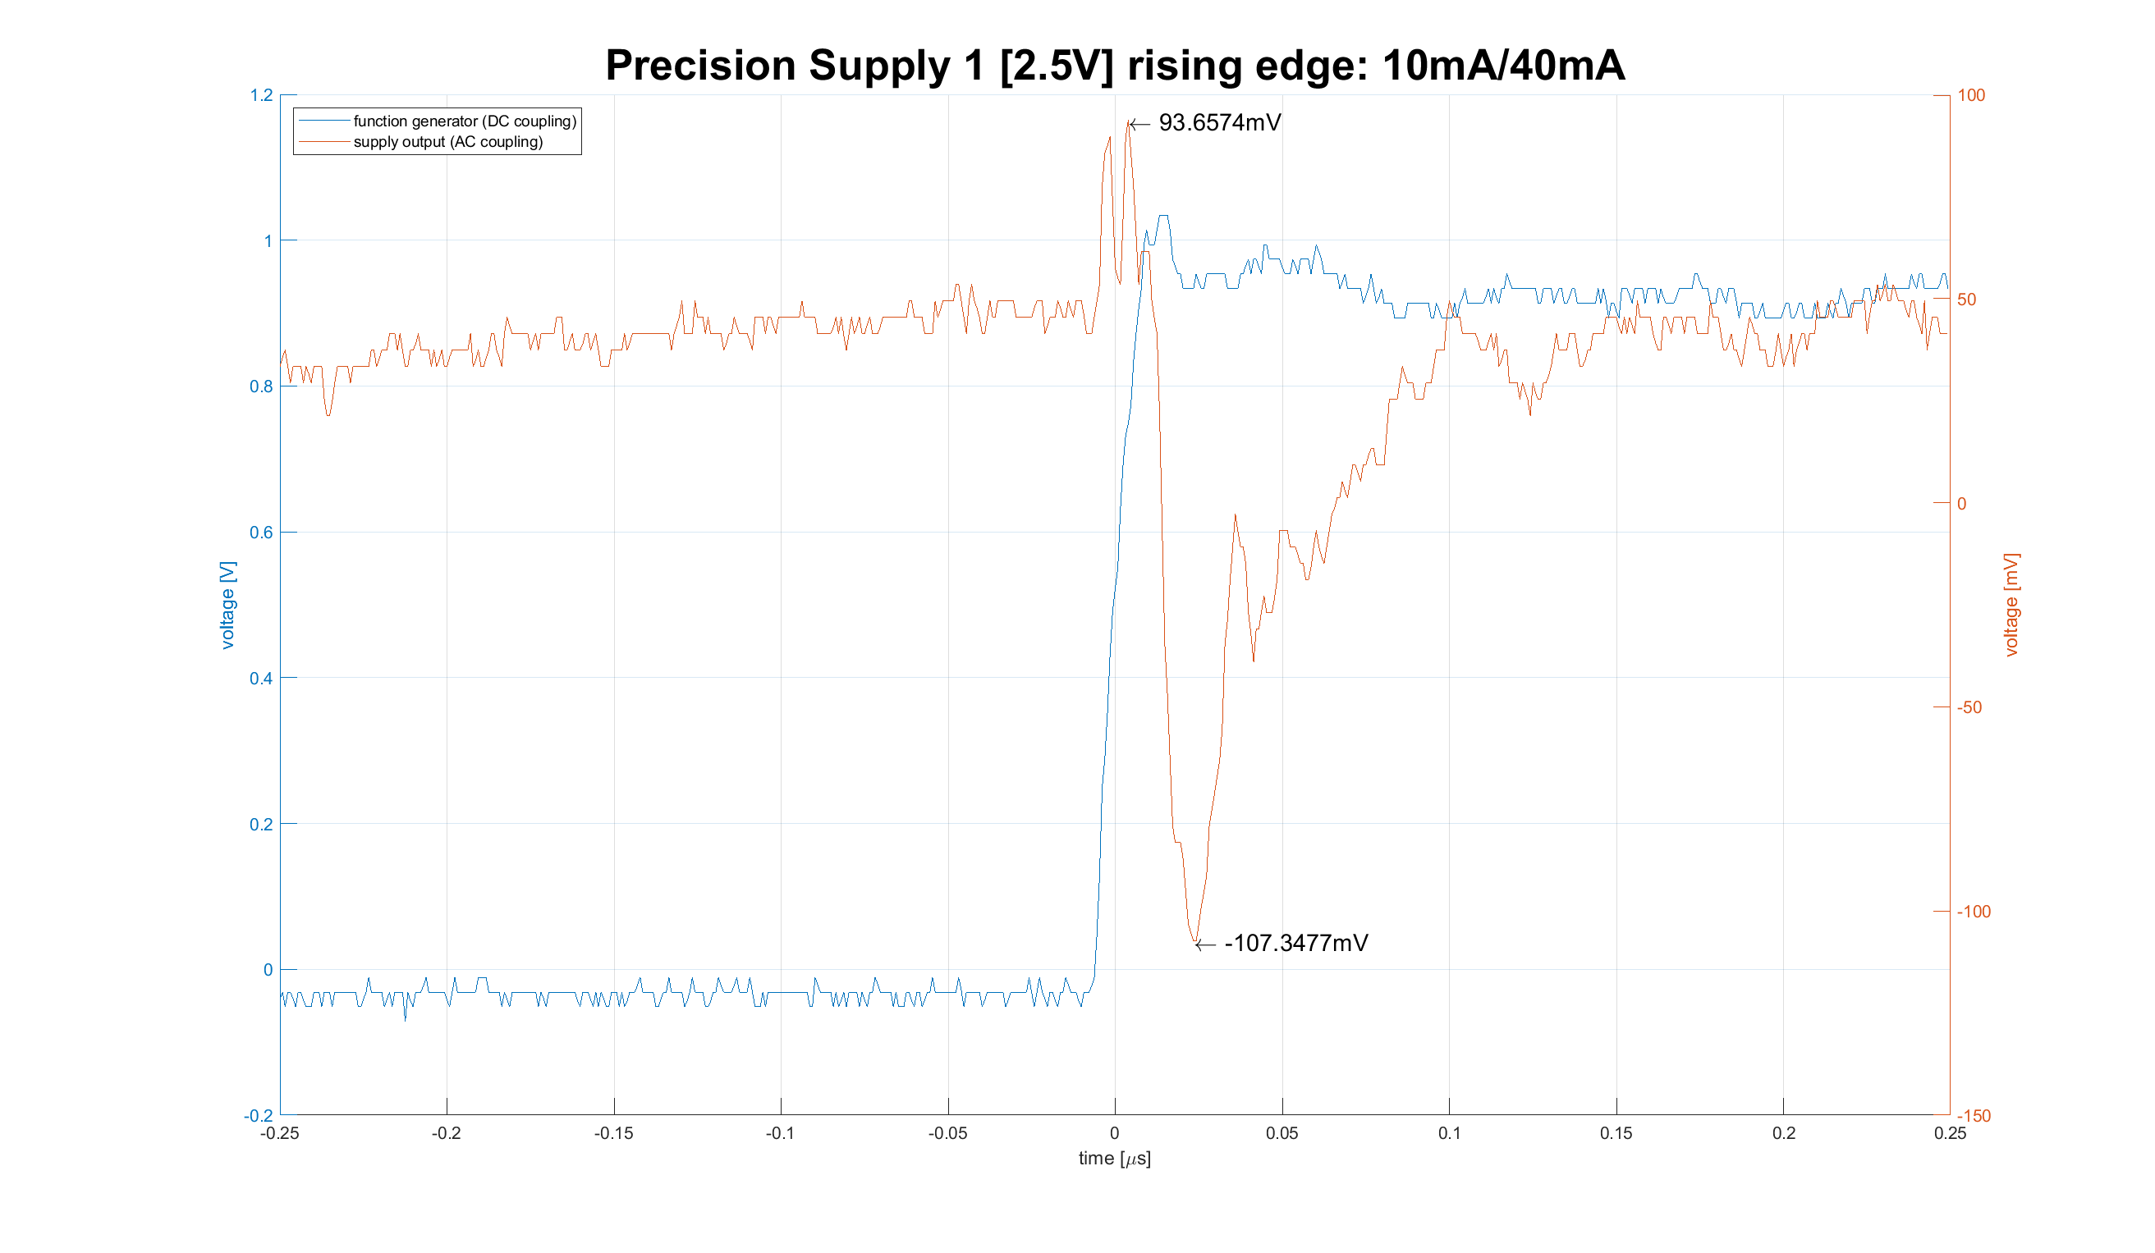

## Precision Supply 2

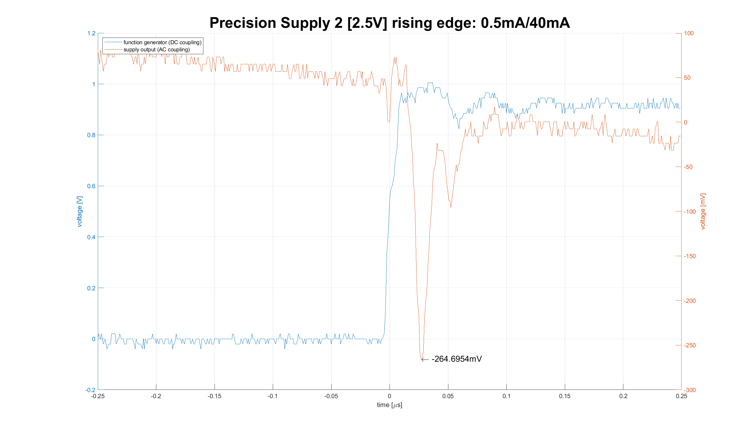

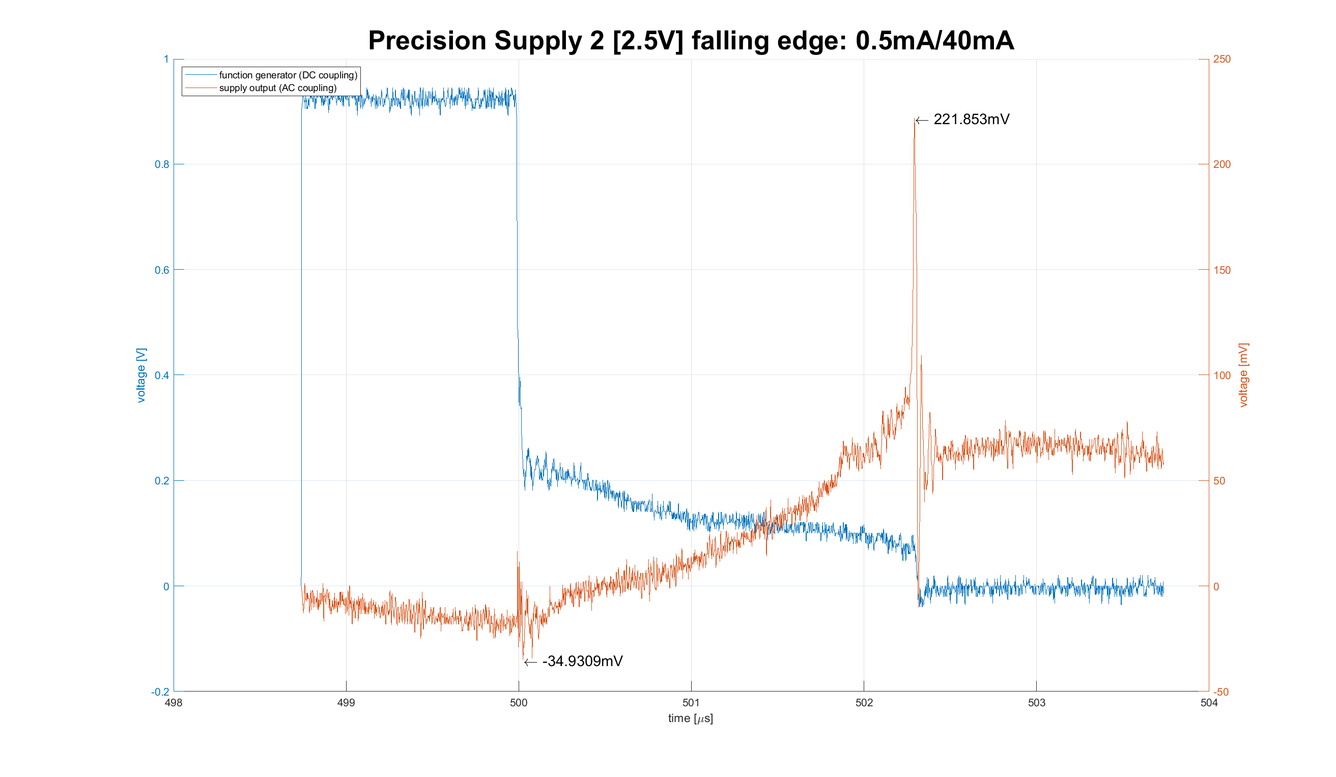

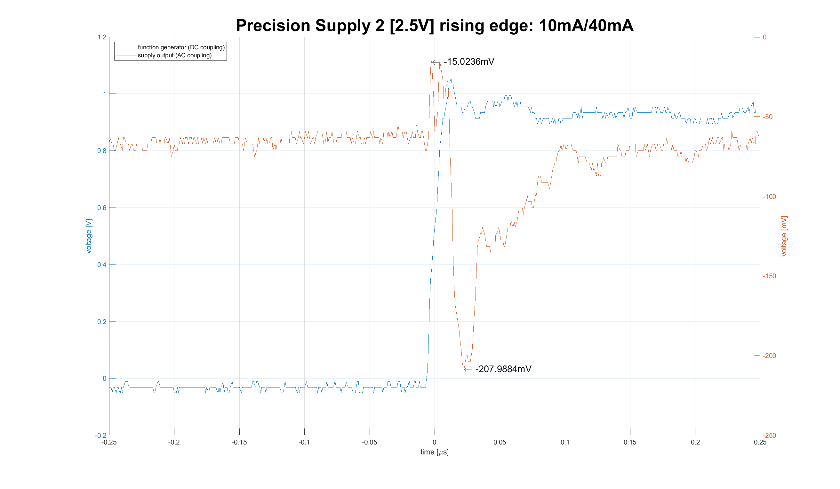

## Variable Supply 1

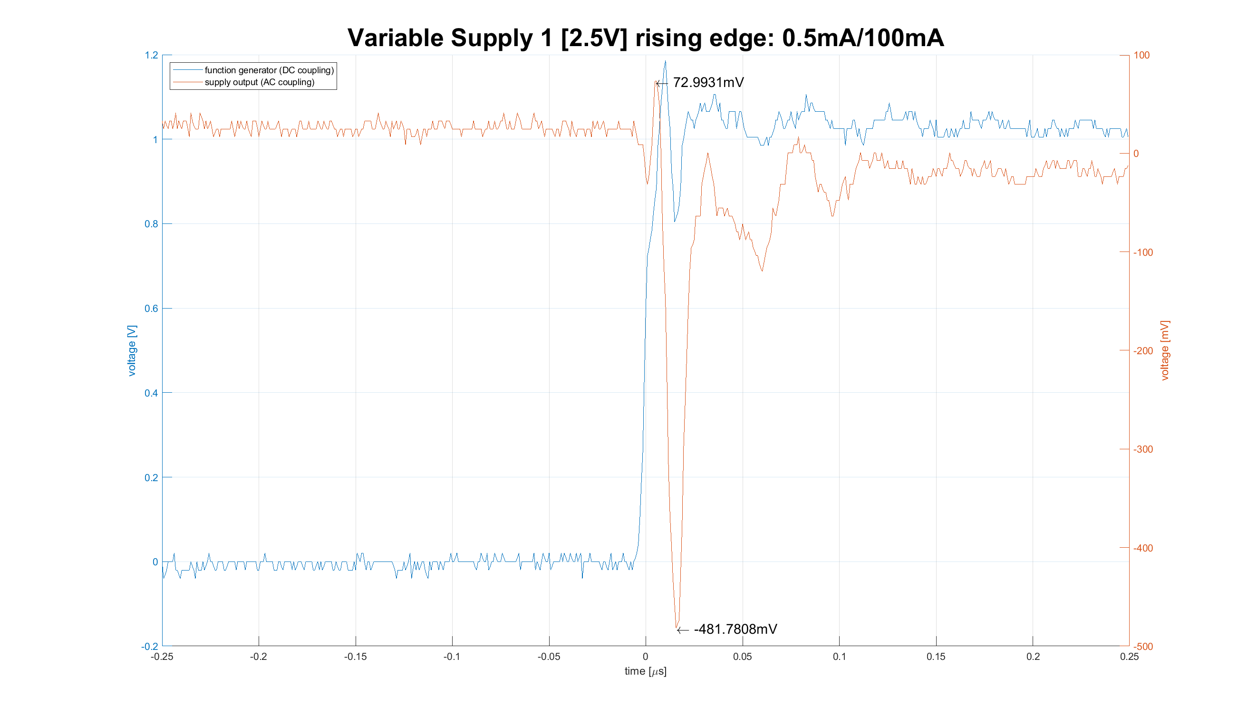

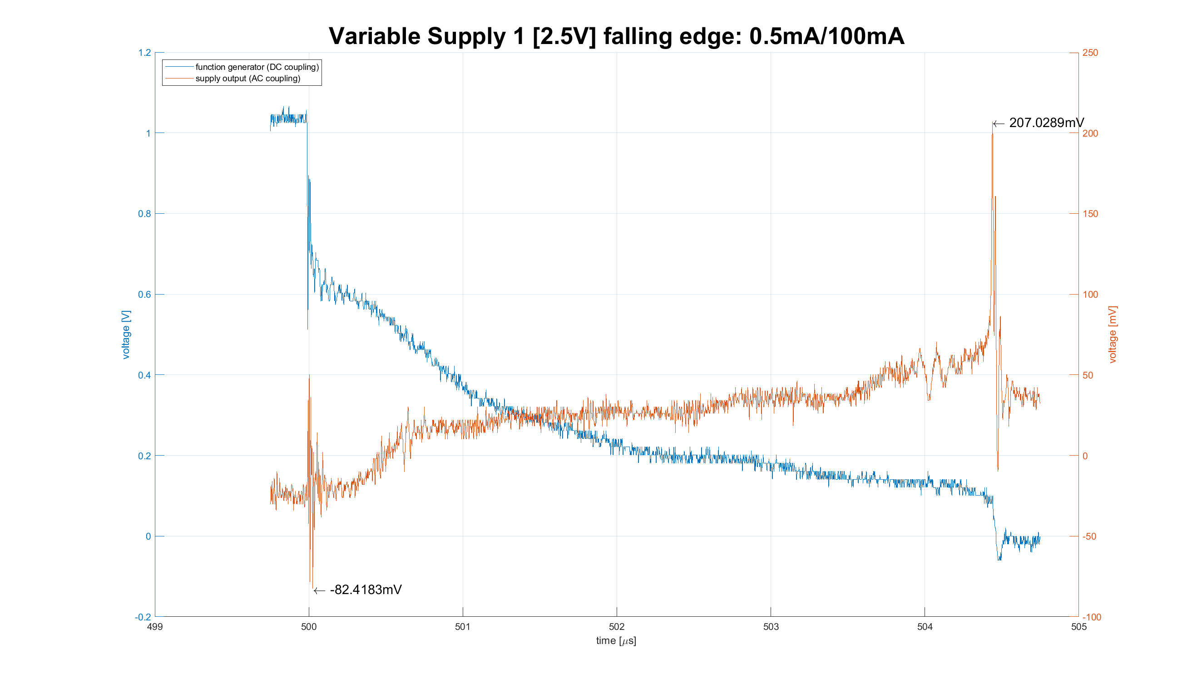

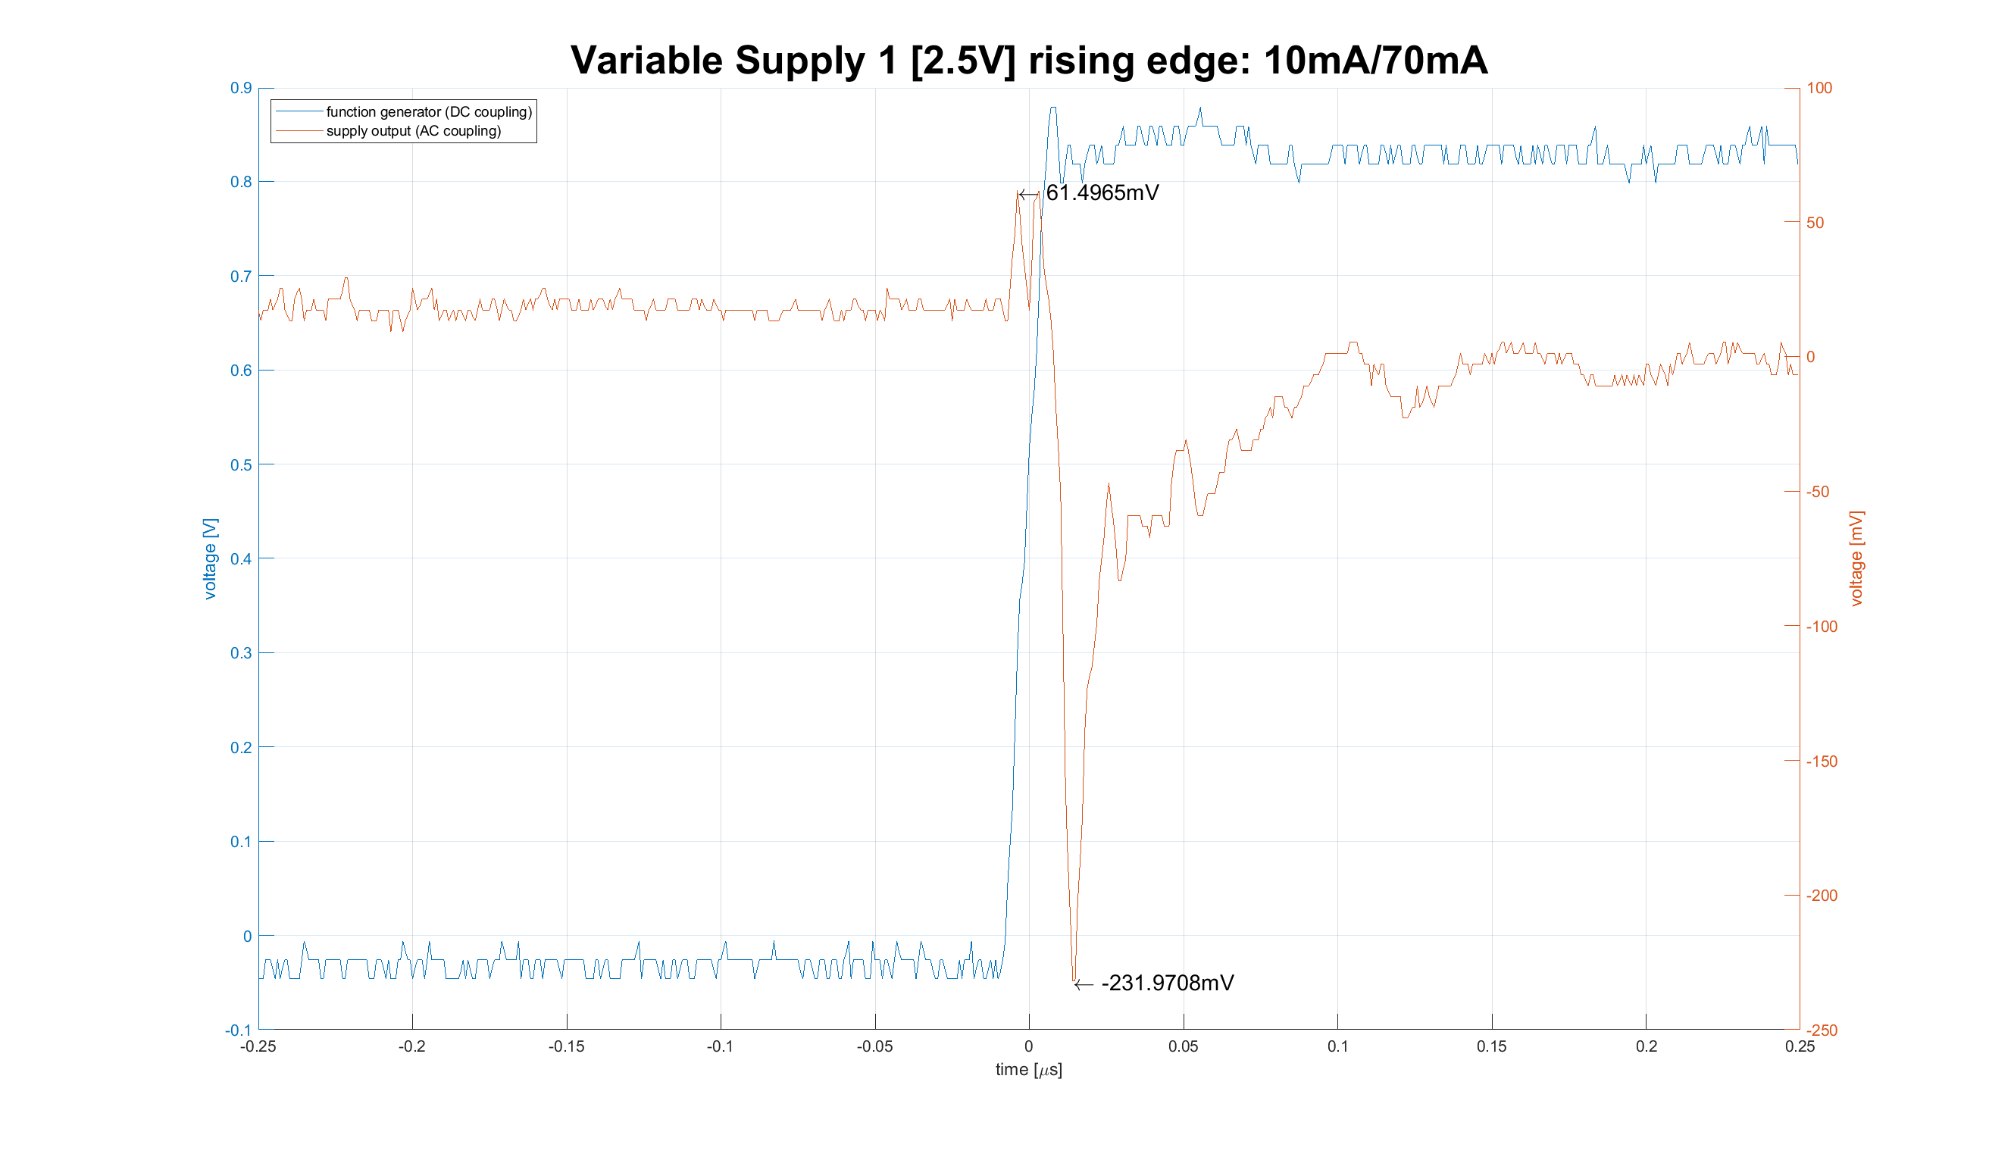

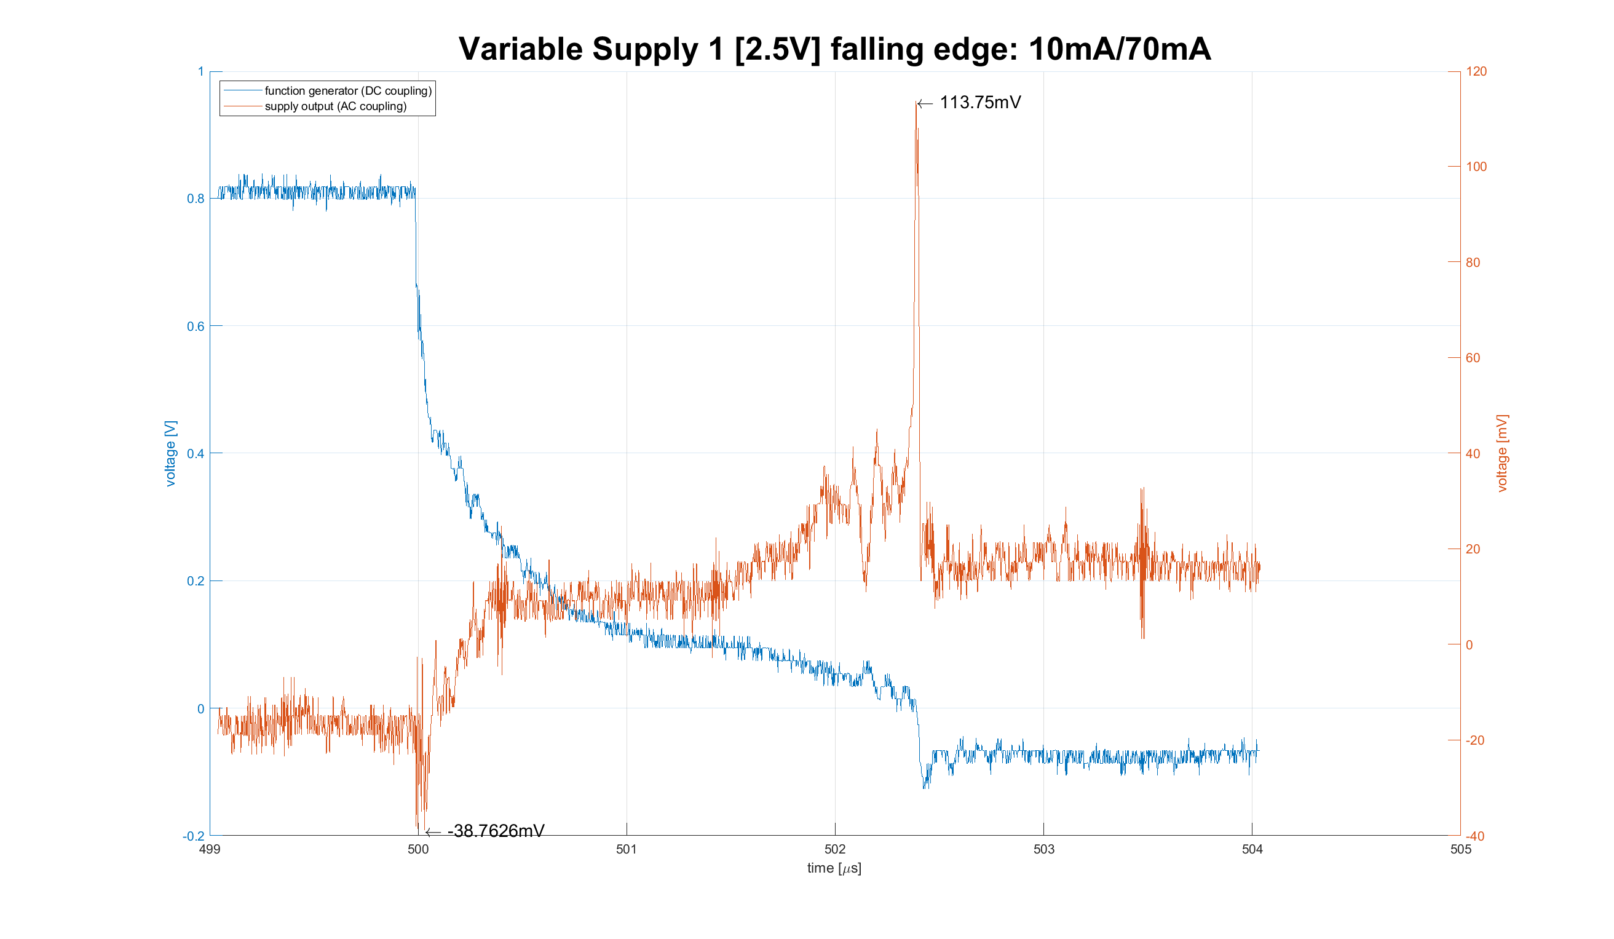

## Variable Supply 2

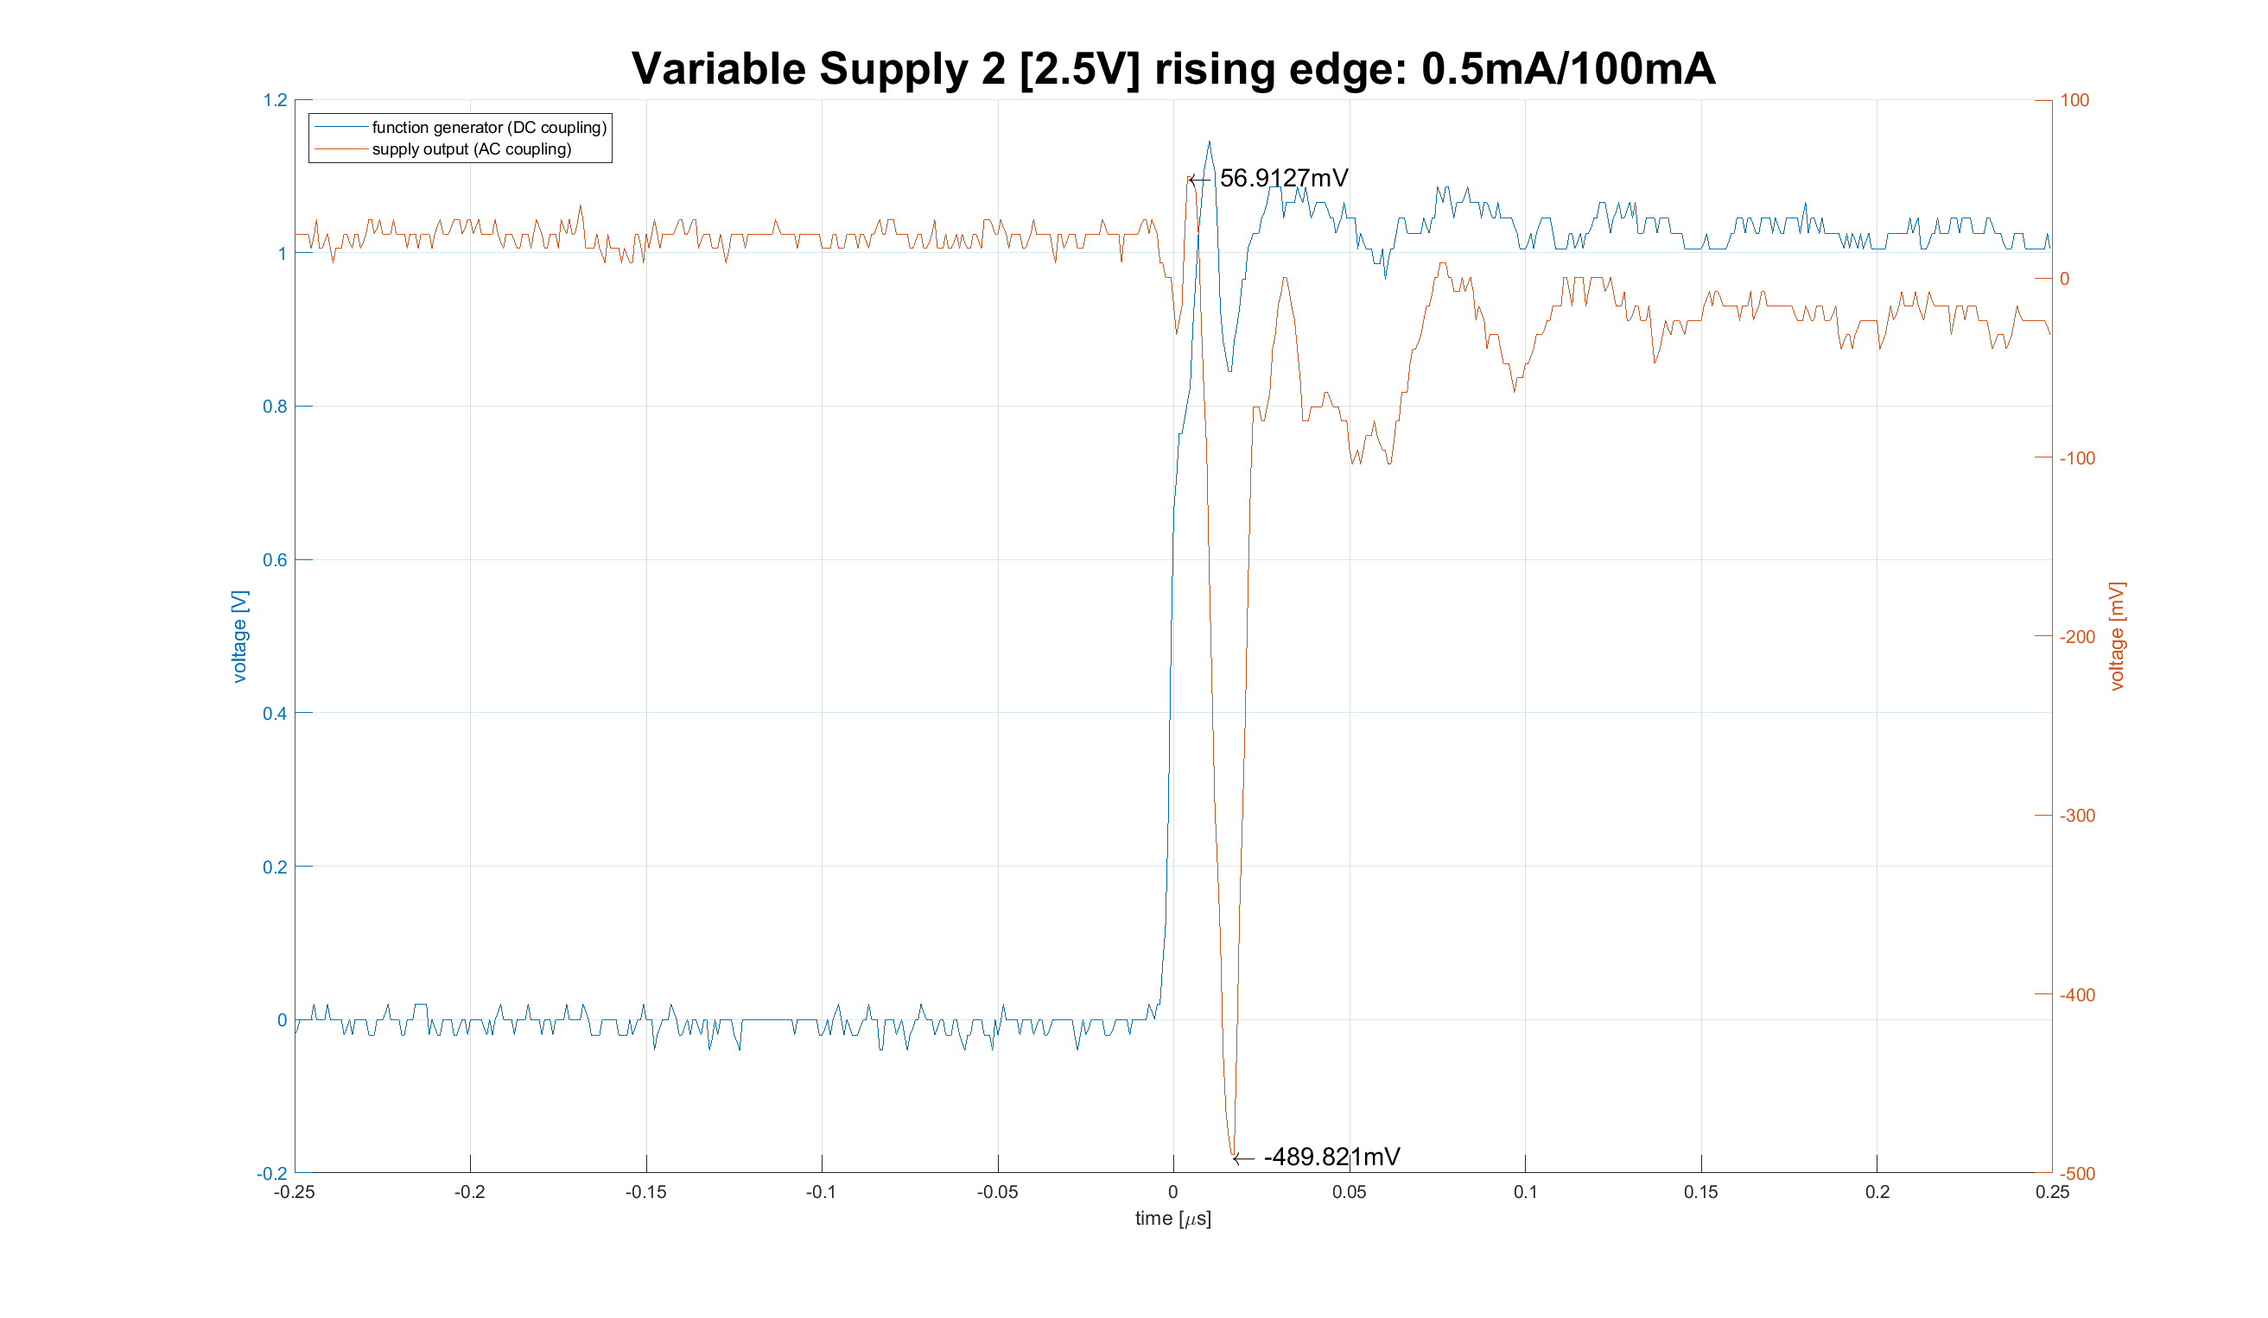

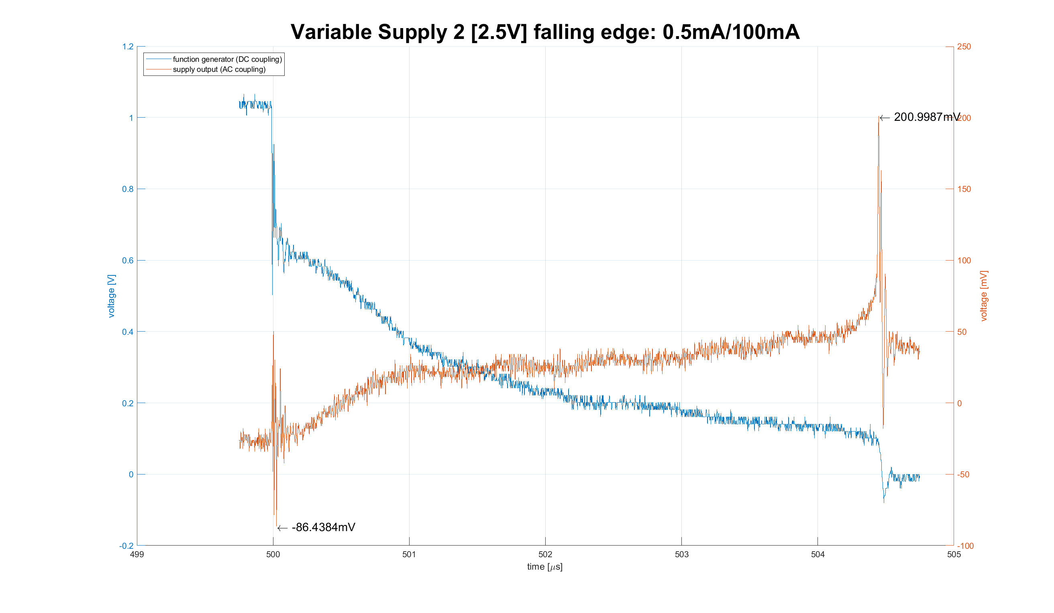

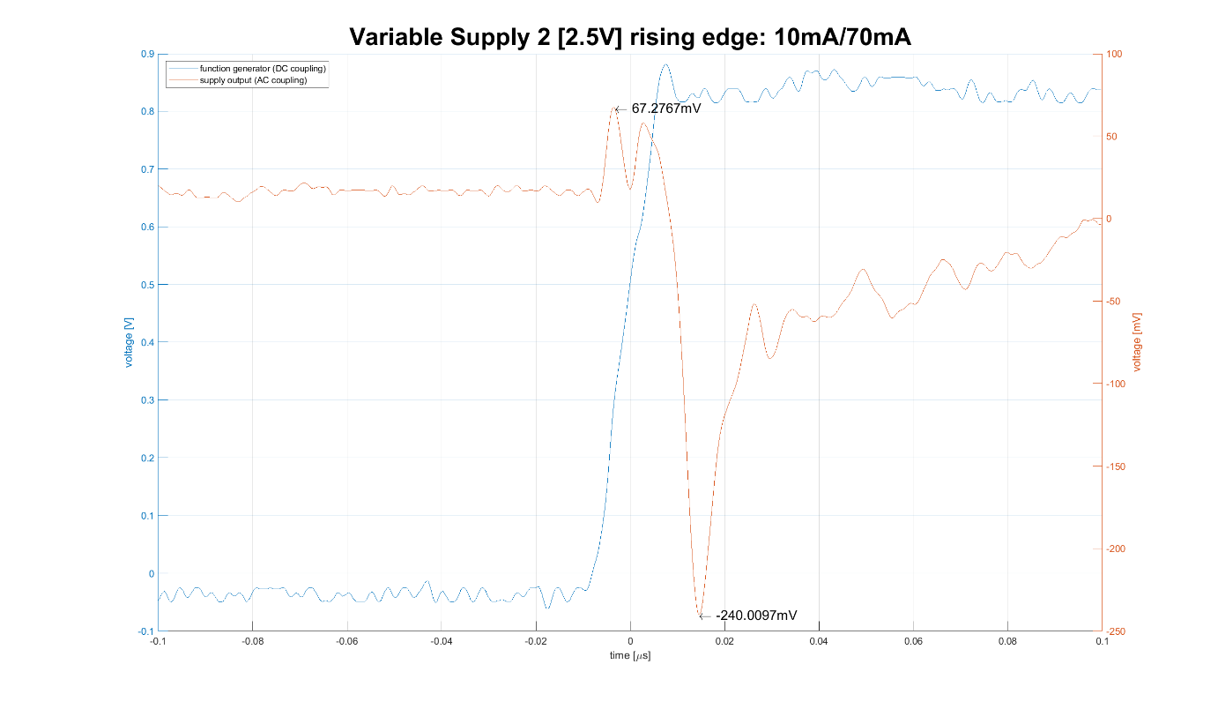

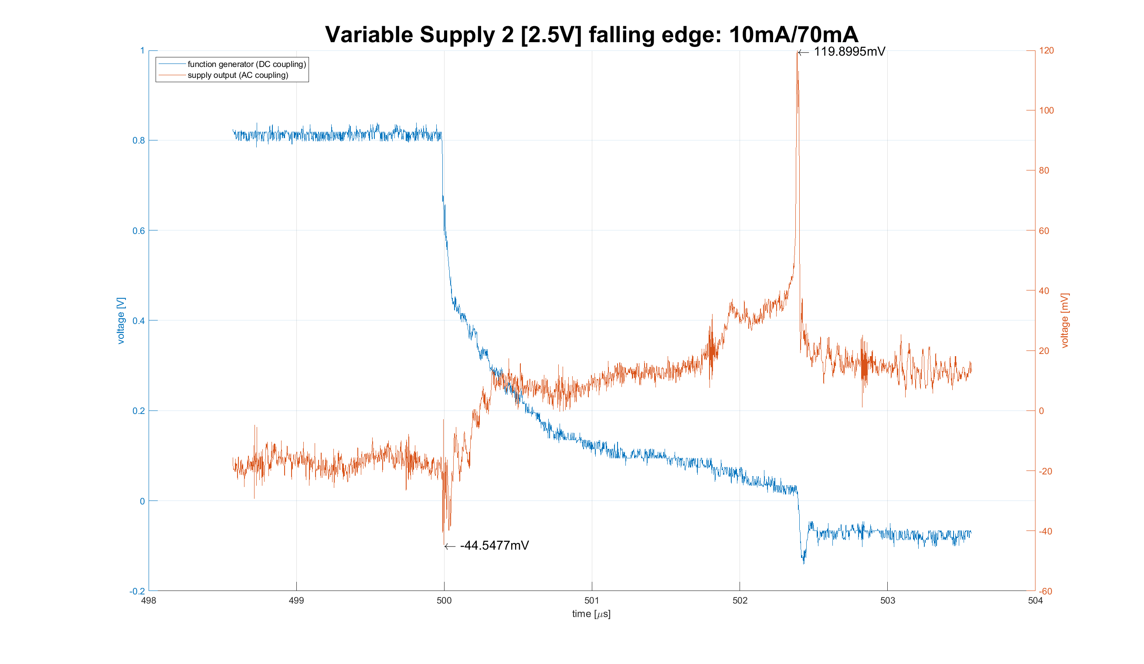

## Variable Supply 3

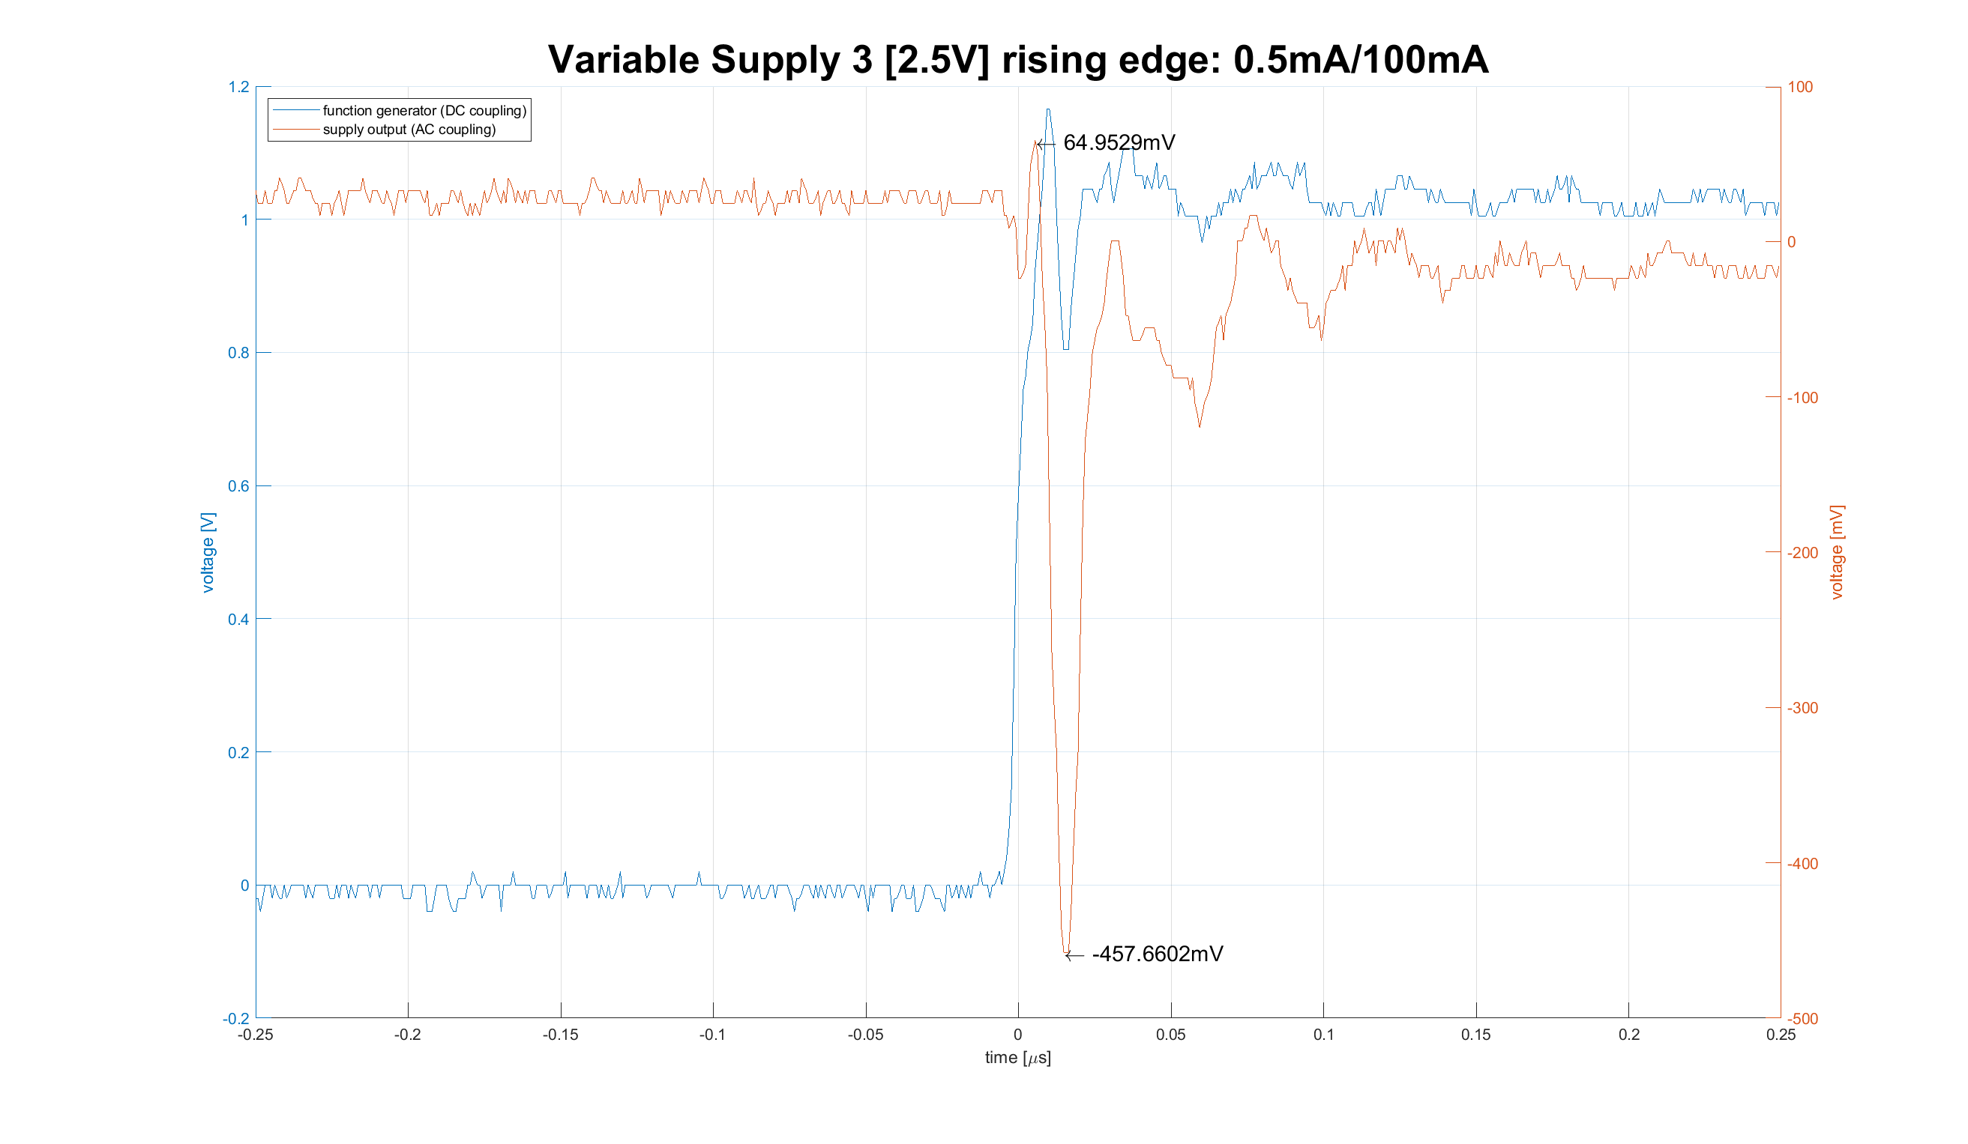

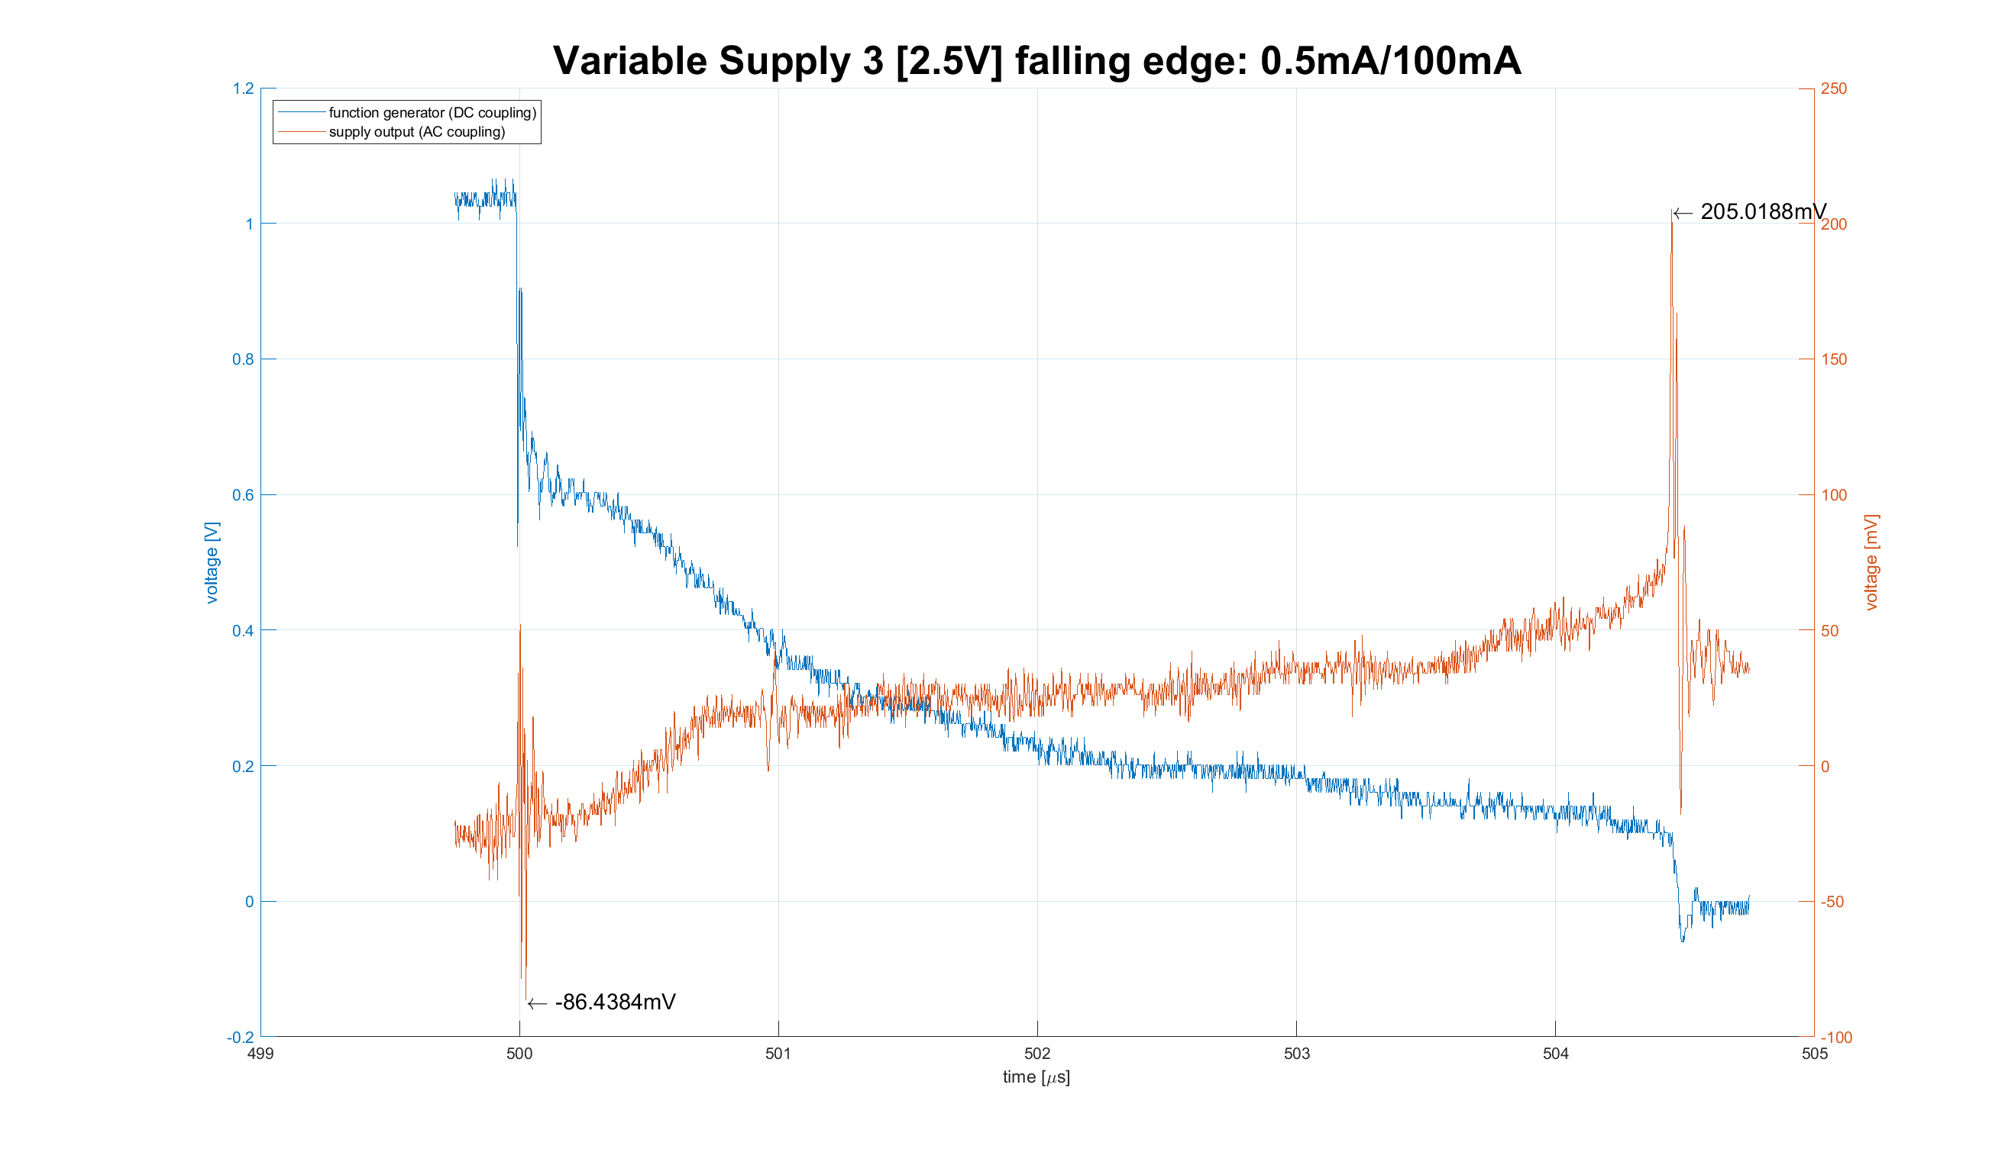

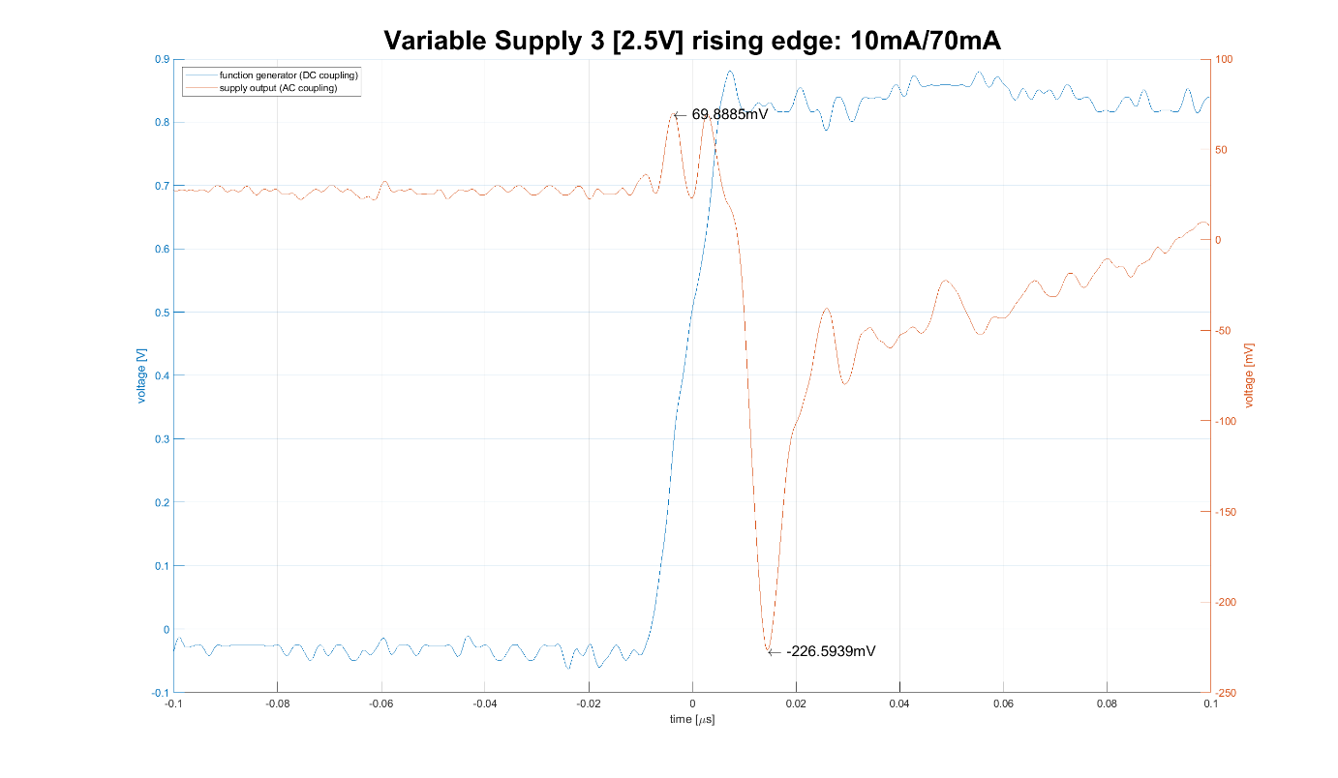

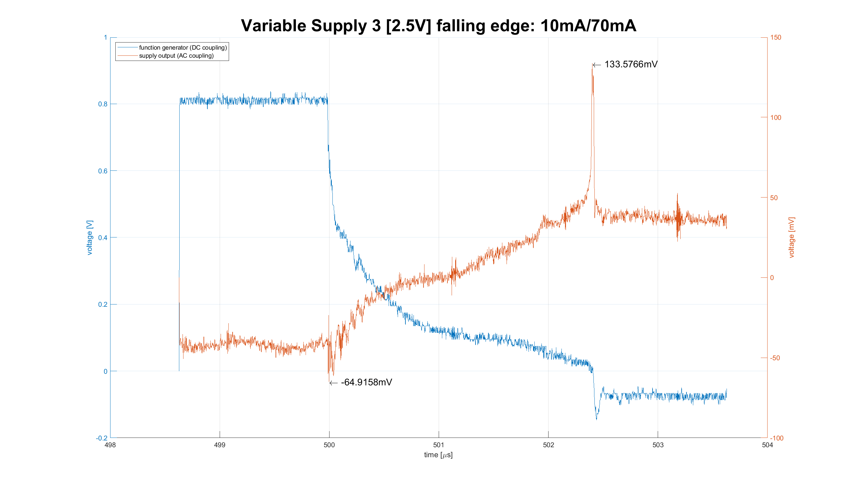

# Measurements

## Voltage

### VM 1

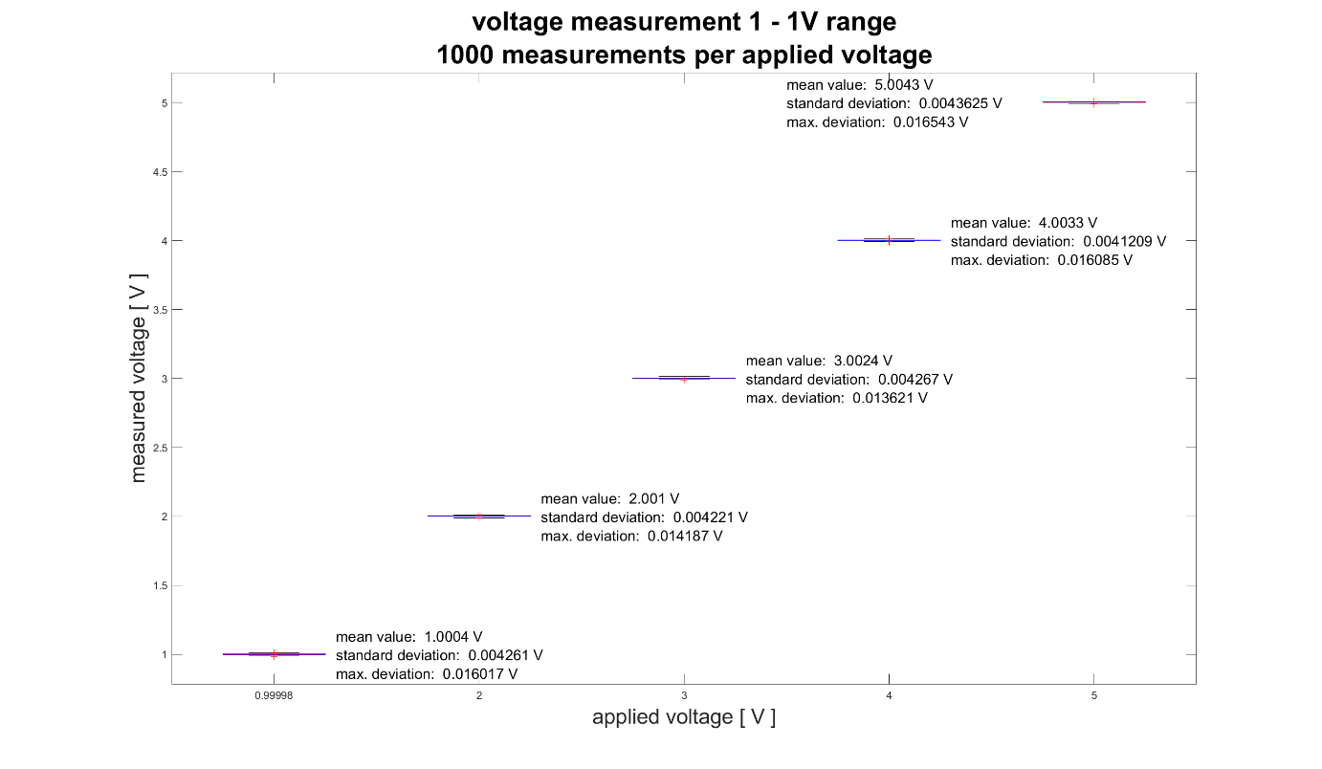

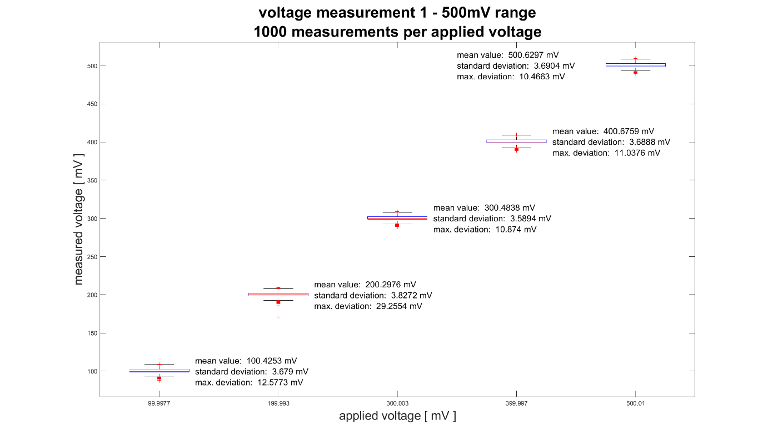

### VM 2

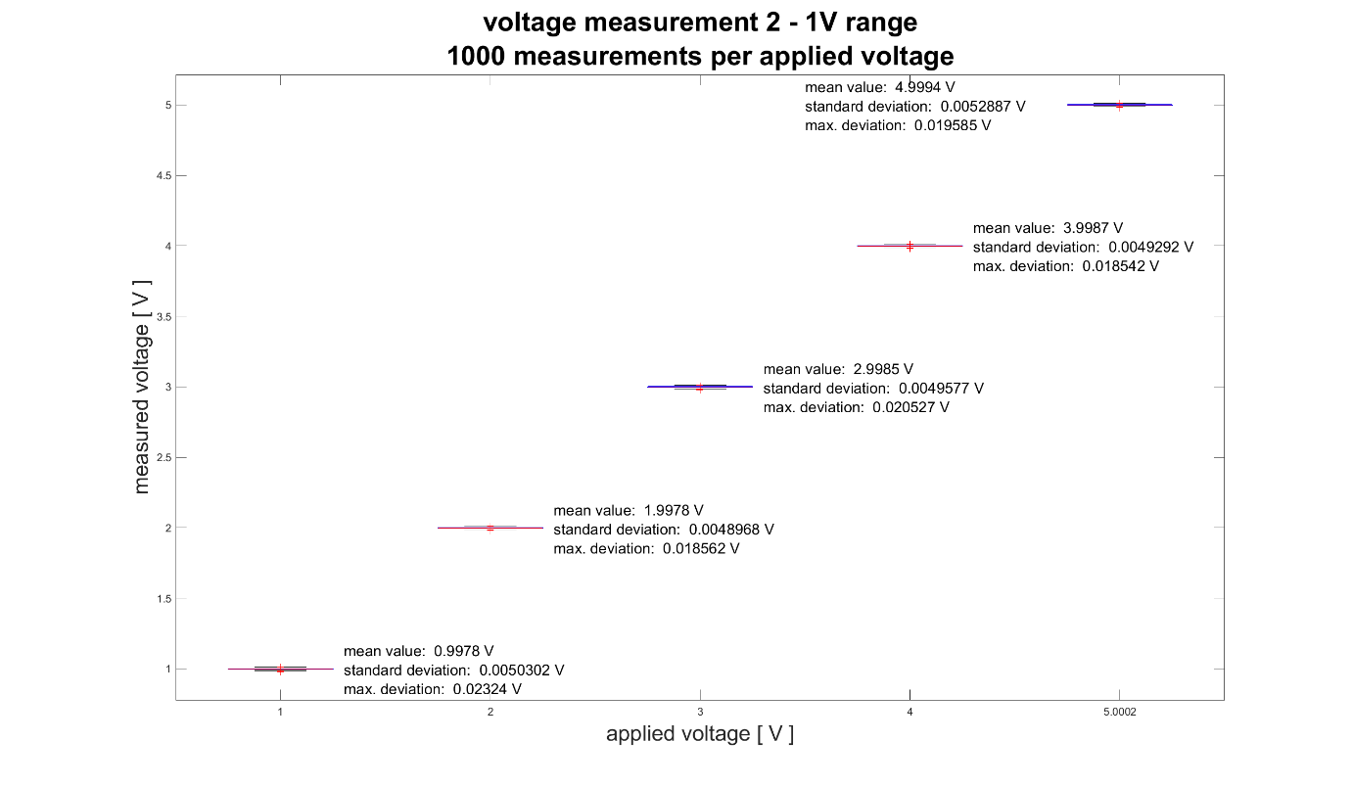

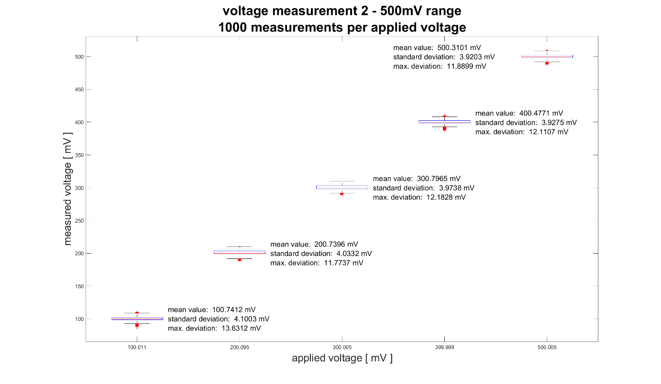

## Current

### CM 3

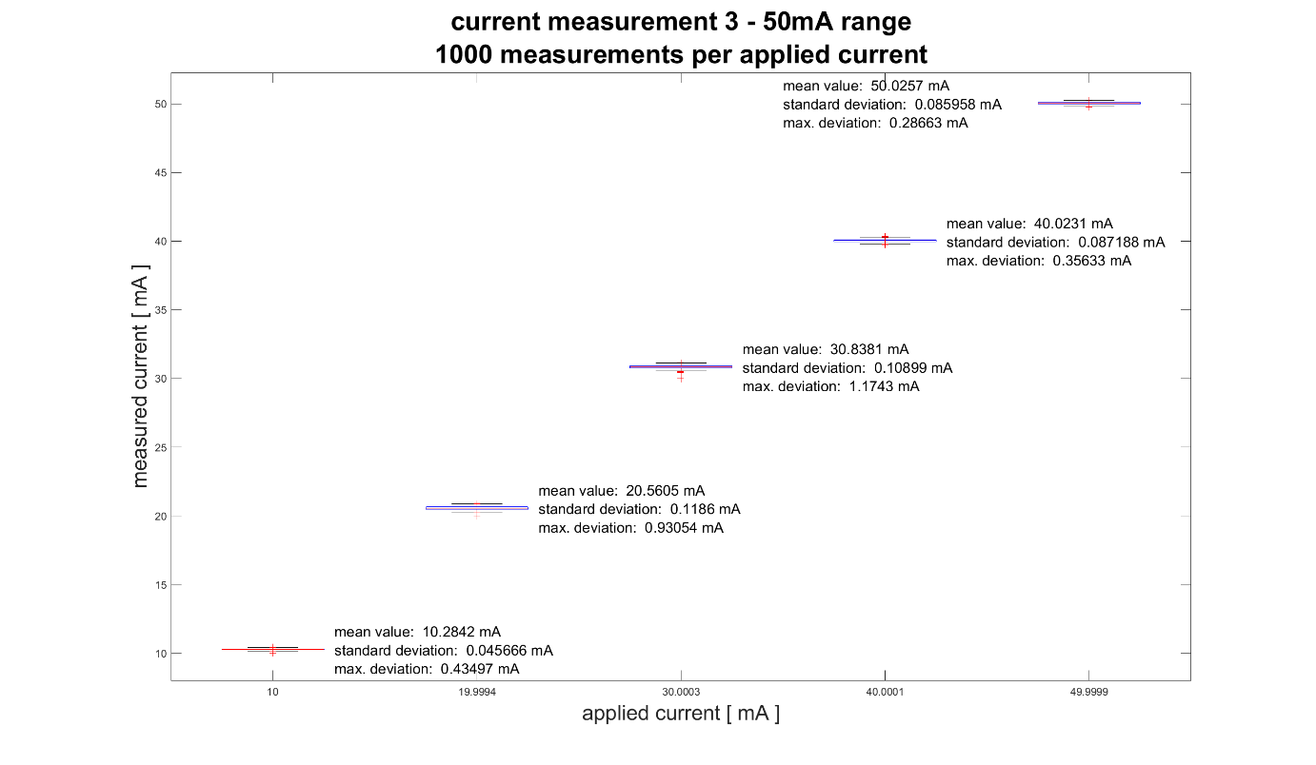

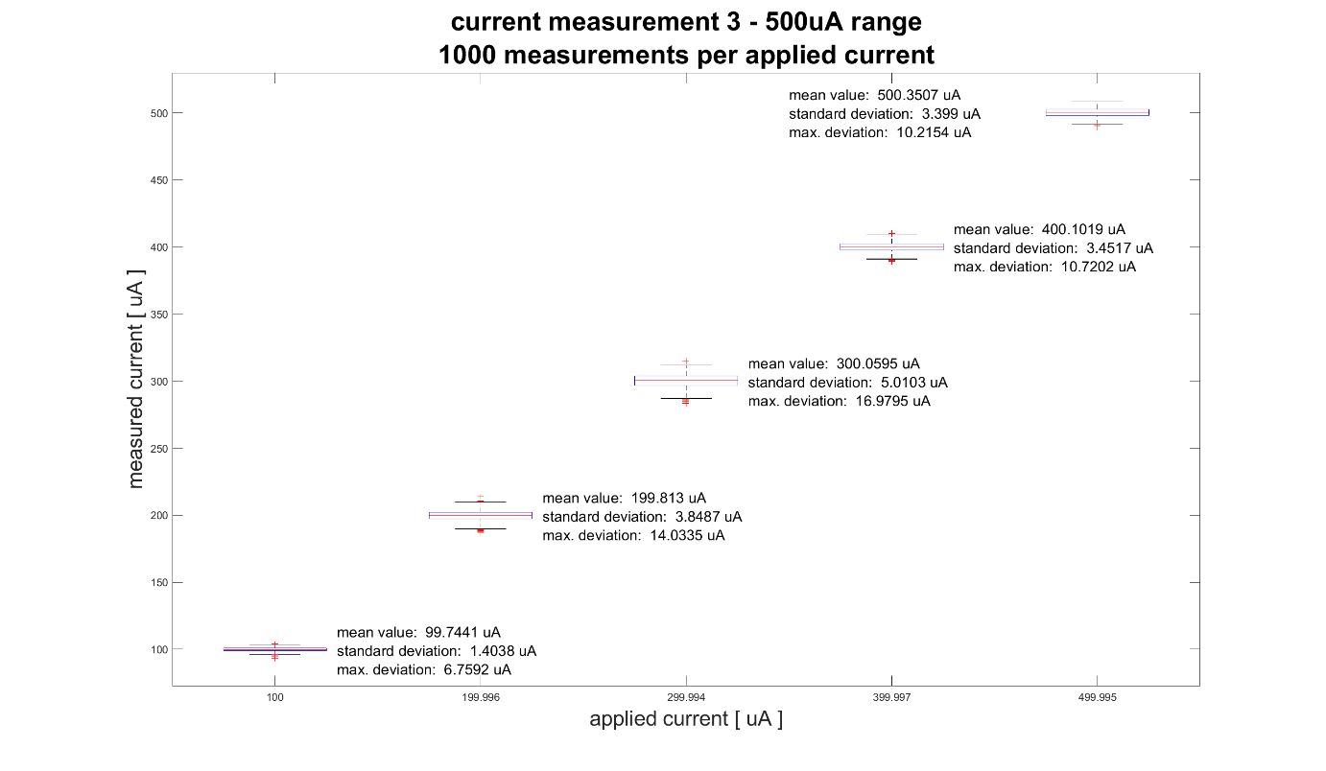

### CM 4

